Chapter 9
Application: International Trade
MULTIPLE CHOICE
1. When goods that are produced in the United States are sold to China, the goods are
a. exported by the United States and imported by China.
b. imported by the United States and exported by China.
c. exported by the United States and exported by China.
d. imported by the United States and imported by China.
ANSWER: a. exported by the United States and imported by China.
TYPE: M SECTION: 0 DIFFICULTY: 2
2. When the United States engages in international trade with China,
a. China reaps economic benefits and the United States loses.
b. both China and the United States reap economic benefits.
c. it is an equal tradeoff so neither country benefits nor loses.
d. China loses and the United States reaps economic benefits.
ANSWER: b. both China and the United States reap economic benefits.
TYPE: M SECTION: 0 DIFFICULTY: 2
3. When Ford and General Motors import automobile parts from Mexico at prices below those they must pay in the United States,
a. workers who assemble Ford and General Motors vehicles become worse off.
b. United States consumers, taken as a group, become worse off.
c. Mexican consumers, taken as a group, become worse off.
d. American companies that manufacture automobile parts become worse off.
ANSWER: d. American companies that manufacture automobile parts become worse off.
TYPE: M SECTION: 0 DIFFICULTY: 2
4. An industry that was a major part of the U.S. economy a century ago but is not now is the
a. agriculture industry.
b. textile and clothing industry.
c. coal mining industry.
d. automobile industry.
ANSWER: b. textile and clothing industry.
TYPE: M SECTION: 0 DIFFICULTY: 1
5. One reason for the decline in the U.S. textile industry was
a. foreign competition.
b. an increase in raw material prices.
c. a decrease in U.S. demand for clothing.
d. the enactment of the U.S. minimum wage law.
ANSWER: a. foreign competition.
TYPE: M SECTION: 0 DIFFICULTY: 1
6. Countries usually impose restrictions on free foreign trade to protect
a. foreign producers.
b. foreign consumers.
c. domestic producers.
d. domestic consumers.
ANSWER: c. domestic producers.
TYPE: M SECTION: 1 DIFFICULTY: 2
7. If a country allows trade and the domestic price of a good is higher than the world price,
a. the country will become an exporter of the good.
b. the country will become an importer of the good.
c. the country will neither export nor import the good.
d. additional information about demand is needed to determine whether the country will export or import the good.
ANSWER: b. the country will become an importer of the good.
TYPE: M SECTION: 1 DIFFICULTY: 2
8. If a country allows trade and the domestic price of a good is lower than the world price,
a. the country will become an exporter of the good.
b. the country will become an importer of the good.
c. the country will neither export nor import the good.
d. additional information about demand is needed to determine whether the country will export or import the good.
ANSWER: a. the country will become an exporter of the good.
TYPE: M SECTION: 1 DIFFICULTY: 2
9. For any country, if the world price of computers is higher than the domestic price of computers, that country should
a. export computers, since that country has a comparative advantage in computers.
b. import computers, since that country has a comparative advantage in computers.
c. not trade computers, since that country cannot gain from trade.
d. not trade, since they already produce computers cheaper than other countries.
ANSWER: a. export computers, since that country has a comparative advantage in computers.
TYPE: M SECTION: 1 DIFFICULTY: 2
10. If the world price of a product is higher than a country’s domestic price we know that country
a. should import that product.
b. should no longer produce that product.
c. has a comparative advantage in that product.
d. could benefit by imposing a tariff on that product.
ANSWER: c. has a comparative advantage in that product.
TYPE: M KEY1: D SECTION: 1 DIFFICULTY: 2
11. If the United States exports cars to France and imports cheese from Switzerland,
a. the United States has a comparative advantage in producing cars, and Switzerland has a comparative advantage in producing cheese.
b. the United States has a comparative advantage in producing cheese, and Switzerland has a comparative advantage in producing cars.
c. the United States and France would both be better off if they each produced cars and cheese.
d. Comparative advantage cannot be determined without knowing absolute prices.
ANSWER: a. the United States has a comparative advantage in producing cars, and Switzerland has a comparative advantage in producing cheese.
TYPE: M SECTION: 1 DIFFICULTY: 3
12. Trade among nations is ultimately based on
a. absolute advantage.
b. political advantage.
c. comparative advantage.
d. technical advantage.
ANSWER: c. comparative advantage.
TYPE: M SECTION: 1 DIFFICULTY: 1
13. A country has a comparative advantage in a product if the world price is
a. lower than its domestic price.
b. higher than its domestic price.
c. equal to its domestic price.
d. None of the above are correct.
ANSWER: b. higher than its domestic price.
TYPE: M SECTION: 1 DIFFICULTY: 2
14. A country has a comparative advantage in a product if
a. it can produce a product more efficiently.
b. its domestic price is below the world price.
c. its domestic price is above the world price.
d. it can benefit from importing the product.
ANSWER: b. its domestic price is below the world price.
TYPE: M SECTION: 1 DIFFICULTY: 2
15. Trade is beneficial because it
a. creates jobs for middlemen.
b. creates jobs for shippers.
c. allows each nation to apply economic pressure on other nations.
d. allows each nation to specialize in doing what it does best.
ANSWER: d. allows each nation to specialize in doing what it does best.
TYPE: M SECTION: 1 DIFFICULTY: 1
16. When two countries choose to engage in international trade,
a. both countries will benefit.
b. one country benefits while the other country loses.
c. since it is an exchange, neither country benefits nor loses.
d. we would need additional information to determine if either country benefits.
ANSWER: a. both countries will benefit.
TYPE: M SECTION: 1 DIFFICULTY: 1
17. Which of the following is NOT a benefit of trade?
a. an increased variety of goods
b. lower costs through economies of scale
c. increased competition
d. an ability to control domestic and world prices
ANSWER: d. an ability to control domestic and world prices
TYPE: M SECTION: 1 DIFFICULTY: 1
18. If Haiti has a comparative advantage in producing sugar, and trade in sugar is allowed,
a. Haiti will become an importer of sugar.
b. Haiti will become an exporter of sugar.
c. Haiti could become either an exporter or an importer of sugar.
d. it is impossible to determine whether Haiti will become an importer or an exporter of sugar without additional information about sugar prices.
ANSWER: b. Haiti will become an exporter of sugar.
TYPE: M SECTION: 1 DIFFICULTY: 2
19. When a country allows trade and becomes an exporter of a good domestic producers
a. gain and domestic consumers lose.
b. lose and domestic consumers gain.
c. and domestic consumers both gain.
d. and domestic consumers both lose.
ANSWER: a. gain and domestic consumers lose.
TYPE: M SECTION: 1 DIFFICULTY: 3
20. When a country allows trade and becomes an importer of a good,
a. both domestic producers and domestic consumers are better off.
b. domestic producers are better off, and domestic consumers are worse off.
c. domestic producers are worse off, and domestic consumers are better off.
d. both domestic producers and domestic consumers are worse off.
ANSWER: c. domestic producers are worse off, and domestic consumers are better off.
TYPE: M SECTION: 2 DIFFICULTY: 3
21. When a country allows trade and becomes an importer of a good,
a. everyone in the country benefits.
b. the gains of the winners exceed the losses of the losers.
c. the losses of the losers exceed the gains of the winners.
d. everyone in the country loses.
ANSWER: b. the gains of the winners exceed the losses of the losers.
TYPE: M SECTION: 2 DIFFICULTY: 2
22. Trade raises the economic well-being of a nation in the sense that
a. the gains of the winners exceed the losses of the losers.
b. everyone in an economy gains from trade.
c. since countries can choose what products to trade, they will pick those products that are most beneficial to society.
d. trade increases a country’s gross domestic product (GDP).
ANSWER: a. the gains of the winners exceeds the losses of the losers.
TYPE: M SECTION: 1 DIFFICULTY: 2
23. When a country allows trade and becomes an exporter of a good,
a. everyone in the country benefits.
b. everyone in the country loses.
c. the gains of the winners exceed the losses of the losers.
d. the losses of the losers exceed the gains of the winners.
ANSWER: c. the gains of the winners exceed the losses of the losers.
TYPE: M SECTION: 2 DIFFICULTY: 2
24. When a country allows trade and becomes an exporter of a good, which of the following would NOT be true?
a. The price paid by domestic consumers of the good increases.
b. The price received by domestic producers of the good increases.
c. The losses of domestic consumers exceed the gains of domestic producers.
d. The gains of domestic producers exceed the losses of domestic consumers.
ANSWER: c. The losses of domestic consumers exceed the gains of domestic producers.
TYPE: M SECTION: 2 DIFFICULTY: 3
25. When a country allows trade and becomes an importer of a good, which of the following would NOT be true?
a. The gains of domestic consumers exceed the losses of domestic producers.
b. The losses of domestic producers exceed the gains of domestic consumers.
c. The price paid by domestic consumers of the good decreases.
d. The price received by domestic producers of the good decreases.
ANSWER: b. The losses of domestic producers exceed the gains of domestic consumers.
TYPE: M SECTION: 2 DIFFICULTY: 3
26. When a country allows trade and becomes an exporter of a good consumer surplus
a. and producer surplus will increase.
b. and producer surplus will decrease.
c. will increase and producer surplus will decrease.
d. will decrease and producer surplus will increase.
ANSWER: d. will decrease and producer surplus will increase.
TYPE: M SECTION: 2 DIFFICULTY: 3
27. When a country allows trade and becomes an importer of a good consumer surplus
a. and producer surplus will increase.
b. and producer surplus will decrease.
c. will increase and producer surplus will decrease.
d. will decrease and producer surplus will increase.
ANSWER: c. will increase and producer surplus will decrease.
TYPE: M SECTION: 2 DIFFICULTY: 3
28. When a country allows free trade,
a. the domestic price will be greater than the world price.
b. the domestic price will be lower than the world price.
c. the domestic price will equal the world price.
d. it does not matter what the world price is; the domestic price is the prevailing price.
ANSWER: c. the domestic price will equal the world price.
TYPE: M SECTION: 2 DIFFICULTY: 2
29. The domestic price of a product will equal the world price
a. when the domestic supply of the product increases.
b. when the country allows free trade.
c. when trade restrictions are imposed on the product.
d. if the country chooses to export and not import the product.
ANSWER: b. when the country allows free trade.
TYPE: M SECTION: 2 DIFFICULTY: 2
30. For any country which allows free trade,
a. domestic quantity demanded must equal domestic quantity supplied at the world price.
b. if the world price equals the domestic price for a product, the country can choose to either import or export the product.
c. both producers and consumers in that country will gain from trade.
d. the domestic price will equal the world price.
ANSWER: d. the domestic price will equal the world price.
TYPE: M SECTION: 1 DIFFICULTY: 2
31. Benefits from free trade include each of the following EXCEPT
a. increased variety of goods.
b. lower costs because of economies of scale.
c. enhanced flow of ideas.
d. reduced competition.
ANSWER: d. reduced competition.
TYPE: M SECTION: 1 DIFFICULTY: 1
32. Economies of scale exist when goods
a. can be produced at low cost only if they are produced in large quantities.
b. that are identical can be produced at a lower cost then diversified products.
c. are produced by countries which have a comparative advantage in that product.
d. are produced by the lowest cost firm.
ANSWER: a. can be produced at low cost only if they are produced in large quantities.
TYPE: M SECTION: 1 DIFFICULTY: 2
33. The world price of yo-yo’s is $4.00 each. The pre-trade price of yo-yo’s in Taiwan is $3.50 each. If Taiwan allows trade in yo-yo’s we know that Taiwan will
a. import yo-yo’s and the price in Taiwan will be $4.00 each.
b. import yo-yo’s and the price in Taiwan will be $3.50 each.
c. export yo-yo’s and the price in Taiwan will be $4.00 each.
d. export yo-yo’s and the price in Taiwan will be $3.50 each.
ANSWER: c. export yo-yo’s and the price in Taiwan will be $4.00.
TYPE: M SECTION: 2 DIFFICULTY: 3
34. The world price of yo-yo’s is $4.00 each. The pre-trade price of yo-yo’s in Taiwan is $3.50 each With free trade, in the yo-yo market in Taiwan consumers
a. and producers will both lose.
b. and producers will both benefit.
c. will lose and producers will benefit.
d. will benefit and producers will not be affected.
ANSWER: c. will lose and producers will benefit.
TYPE: M SECTION: 2 DIFFICULTY: 2
35. To correctly analyze the welfare effects of free trade on an economy, economists must assume that the country
a. has a comparative advantage in the product.
b. is the only producer of the product.
c. is a price taker.
d. has an absolute advantage in the product.
ANSWER: c. is a price taker.
TYPE: M SECTION: 1 DIFFICULTY: 2

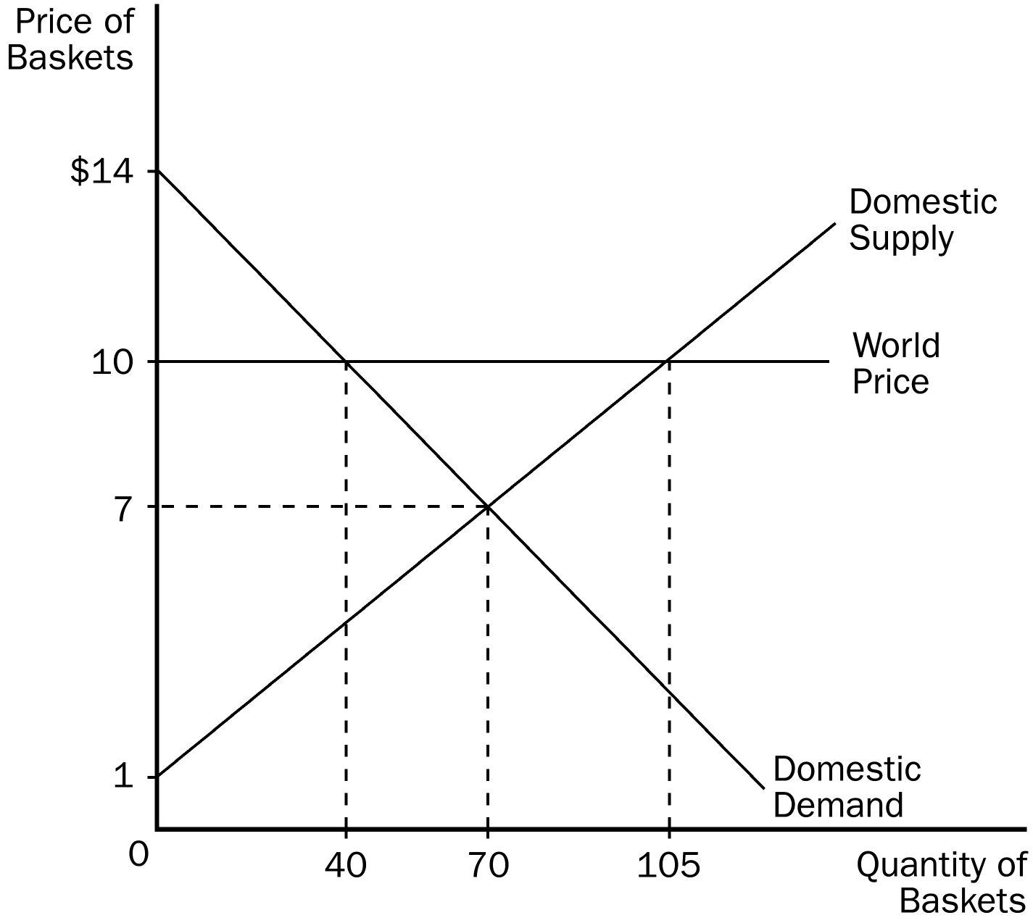
36. According to the graph, without trade, consumer surplus would be
a. $210.
b. $245.
c. $455.
d. $490.
ANSWER: b. $245.
TYPE: M SECTION: 1 DIFFICULTY: 3
37. According to the graph, without trade, producer surplus would be
a. $210.
b. $245.
c. $455.
d. $490.
ANSWER: a. $210.
TYPE: M SECTION: 1 DIFFICULTY: 3
38. According to the graph, with free trade, this country would
a. import 70 baskets.
b. export 65 baskets.
c. export 35 baskets.
d. import 40 baskets.
ANSWER: b. export 65 baskets.
TYPE: M SECTION: 1 DIFFICULTY: 2
39. According to the graph, if this country chooses to trade, the price of baskets in this country would be
a. $10 and 40 would be sold domestically.
b. $10 and 105 would be sold domestically.
c. $7 and 70 would be sold domestically.
d. $7 and 40 would be sold domestically.
ANSWER: a. $10 and 40 would be sold domestically.
TYPE: M SECTION: 1 DIFFICULTY: 3
40. According to the graph, with free trade, consumer surplus would be
a. $45.
b. $80.
c. $210.
d. $245.
ANSWER: b. $80.
TYPE: M SECTION: 1 DIFFICULTY: 3
41. According to the graph, with free trade, producer surplus would be
a. $80.
b. $210.
c. $245.50.
d. $472.50.
ANSWER: d. $472.50.
TYPE: M SECTION: 1 DIFFICULTY: 3
42. According to the graph, with trade, total surplus increases by
a. $80.
b. $97.50.
c. $162.50.
d. $495.50.
ANSWER: b. $97.50.
TYPE: M SECTION: 1 DIFFICULTY: 3
43. According to the graph for this country, at the world price,
a. the domestic quantity demanded is greater than the domestic quantity supplied.
b. the domestic quantity demanded is less than the domestic quantity supplied.
c. the domestic quantity demanded equals the domestic quantity supplied.
d. this country should raise the domestic price of baskets.
ANSWER: b. the domestic quantity demanded is less than the domestic quantity supplied.
TYPE: M SECTION: 1 DIFFICULTY: 2
44. According to the graph, this country
a. has a comparative advantage in baskets.
b. should import baskets.
c. cannot be competitive in the world market.
d. would be better off if the world price for baskets and its pre-trade price were equal.
ANSWER: a. has a comparative advantage in baskets.
TYPE: M SECTION: 1 DIFFICULTY: 2
45. According to the graph, the world price for baskets represents
a. the demand for baskets from the rest of the world.
b. the supply of baskets from the rest of the world.
c. the level of inefficiency in the domestic market caused by trade.
d. the gap between domestic quantity demanded and domestic quantity supplied and the resulting shortage.
ANSWER: a. the demand for baskets from the rest of the world.
TYPE: M SECTION: 1 DIFFICULTY: 2
46. According to the graph, at the world price
a. the domestic quantity demanded is greater than the domestic quantity supplied.
b. the basket market is in equilibrium.
c. the demand curve is perfectly inelastic.
d. both domestic producers and consumers will be better off.
ANSWER: b. the basket market is in equilibrium.
TYPE: M SECTION: 1 DIFFICULTY: 3

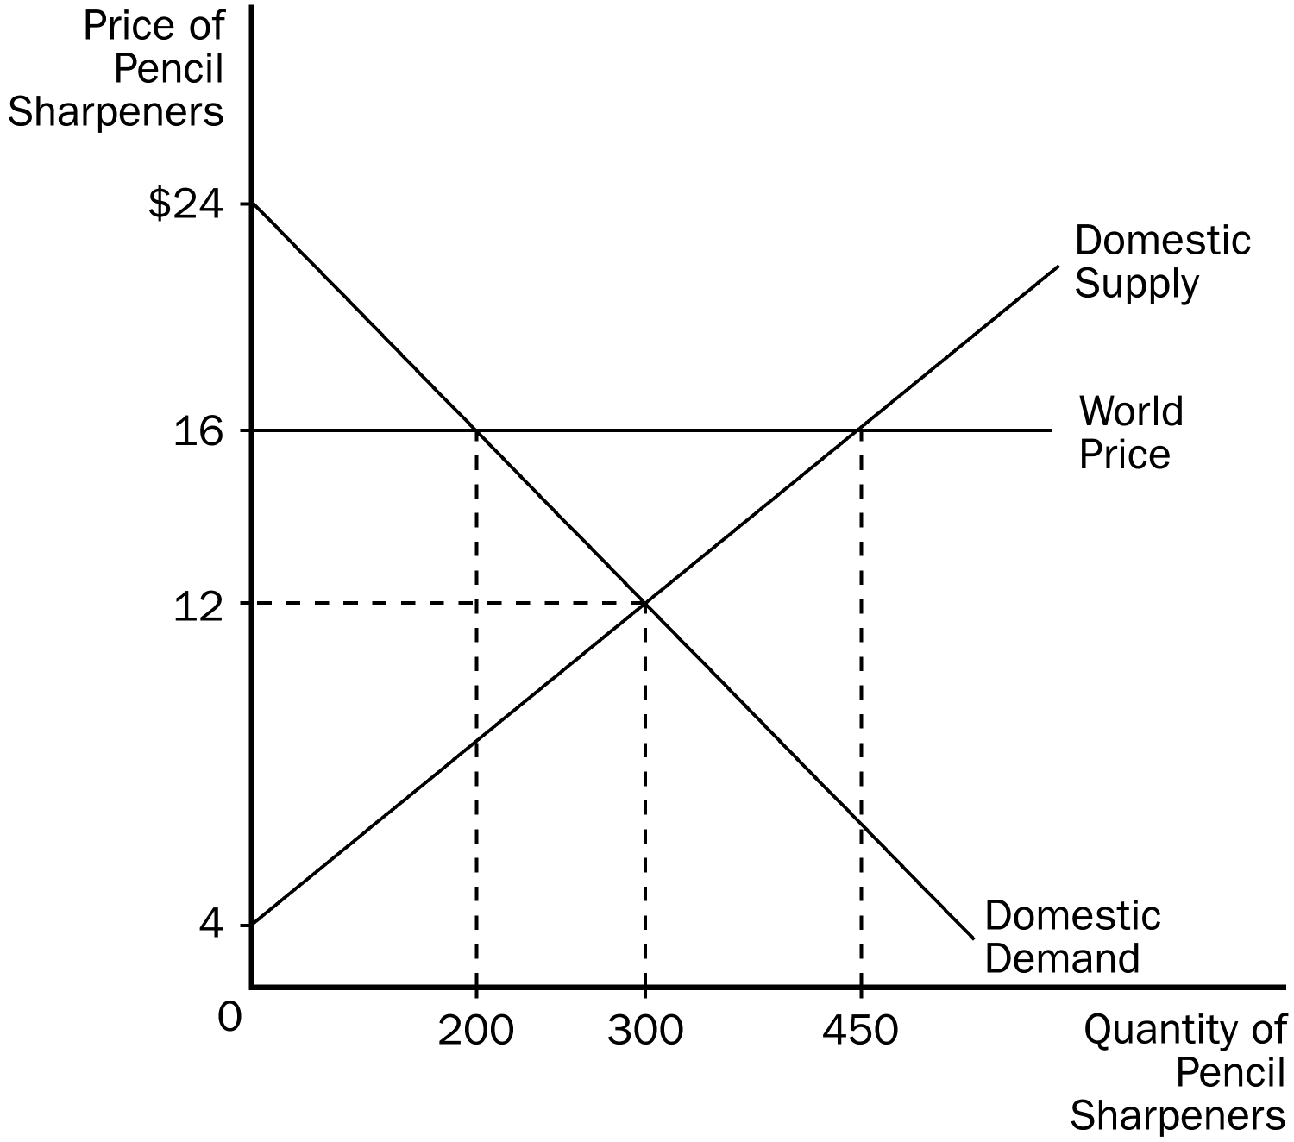
47. According to the graph, China will
a. import 100 pencil sharpeners.
b. import 250 pencil sharpeners.
c. export 100 pencil sharpeners.
d. export 250 pencil sharpeners.
ANSWER: d. export 250 pencil sharpeners.
TYPE: M SECTION: 2 DIFFICULTY: 2
48. According to the graph, producer surplus in China after trade is
a. $800.
b. $1,200.
c. $1,800.
d. $2,700.
ANSWER: d. $2,700.
TYPE: M SECTION: 2
49. According to the graph, the increase in total surplus in China because of trade is
a. $500.
b. $800.
c. $1100.
d. $1600.
ANSWER: a. $500.
TYPE: M SECTION: 2 DIFFICULTY: 2
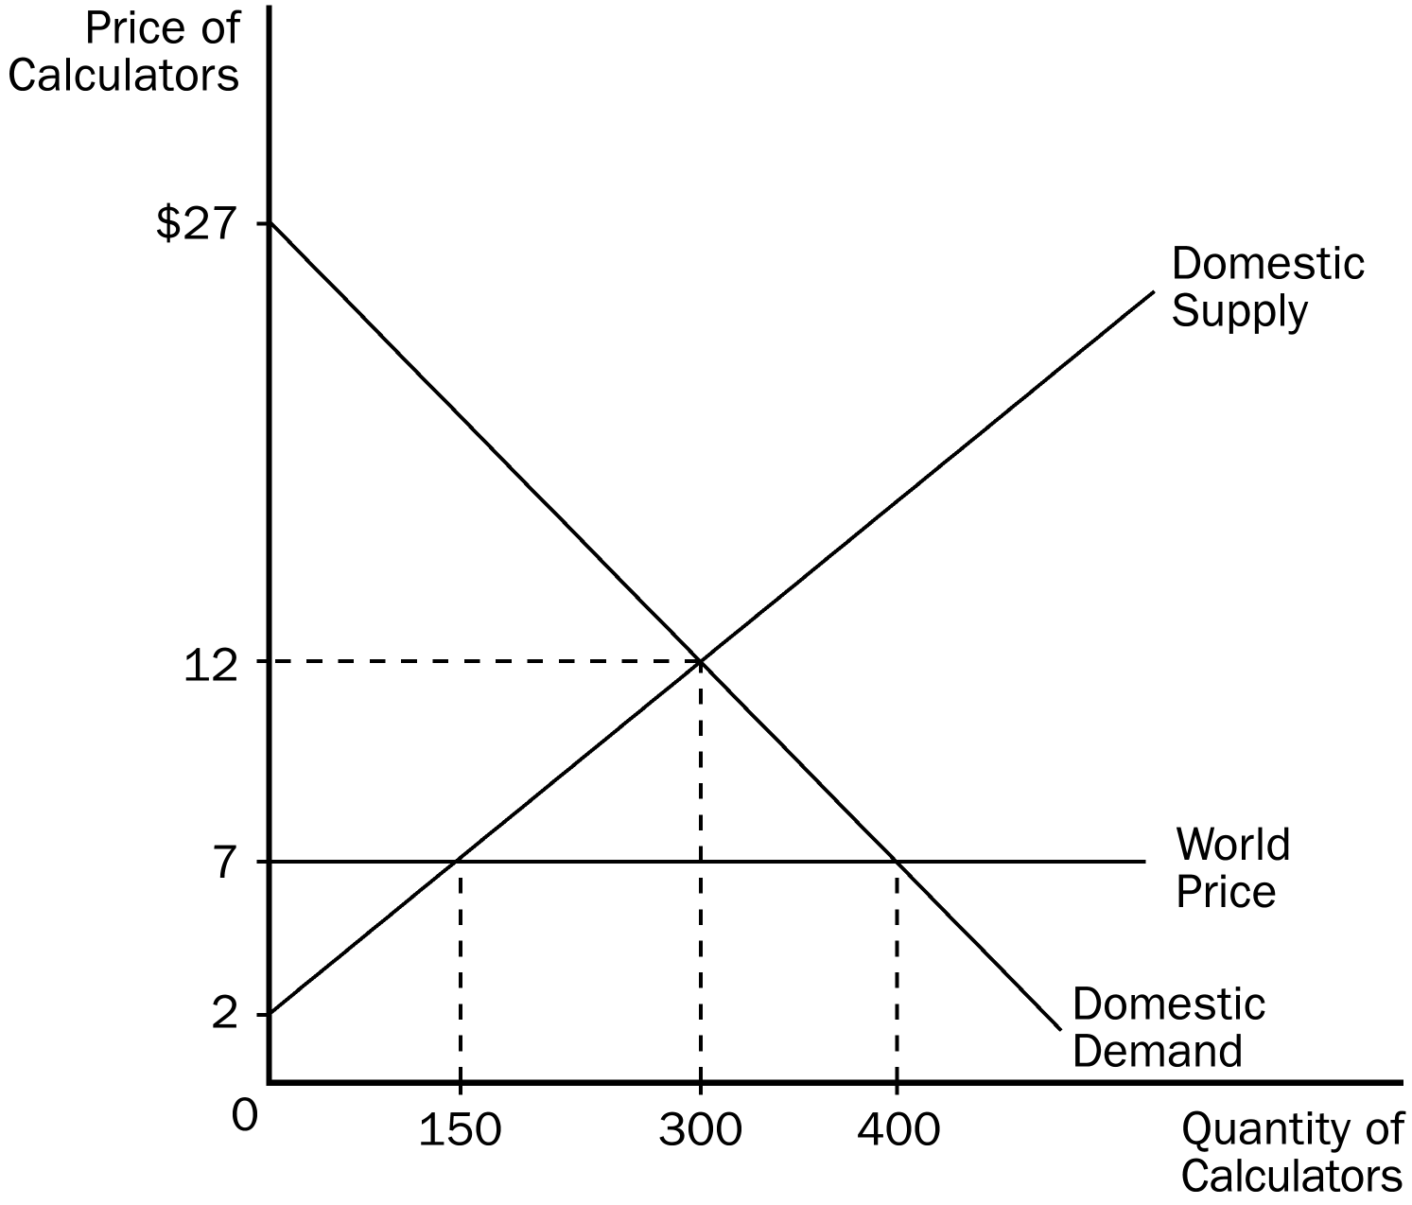
50. According to the graph, Jamaica would
a. import 150 calculators.
b. import 250 calculators.
c. export 100 calculators.
d. export 250 calculators.
ANSWER: b. import 250 calculators.
TYPE: M SECTION: 2 DIFFICULTY: 2
51. According to the graph, consumer surplus in Jamaica before trade is
a. $375.
b. $1,500.
c. $2,250.
d. $8,700.
ANSWER: c. $2,250.
TYPE: M SECTION: 2 DIFFICULTY: 2
52. According to the graph, the change in total surplus in Jamaica because of trade is
a. $625.
b. $865.
c. $1,375.
d. $1,500.
ANSWER: a. $625.
TYPE: M SECTION: 2 DIFFICULTY: 2

The before-trade domestic price of tomatoes in the United States is $500 per ton. The world price of tomatoes is $600 per ton. The U.S. is a price-taker in the tomatoes market.
53. If trade in tomatoes is allowed, the United States
a. will become an importer of tomatoes.
b. will become an exporter of tomatoes.
c. may become either an importer or an exporter of tomatoes.
d. It is impossible to determine whether the United States will become an importer of tomatoes or an exporter of tomatoes.
ANSWER: b. will become an exporter of tomatoes.
TYPE: M SECTION: 2 DIFFICULTY: 2
54. If trade in tomatoes is allowed, the price of tomatoes in the United States
a. will increase.
b. will decrease.
c. will be unaffected.
d. could increase or decrease.
ANSWER: a. will increase.
TYPE: M SECTION: 2 DIFFICULTY: 2
55. If trade in tomatoes is allowed, the price of tomatoes in the United States
a. will be greater than the world price.
b. will be equal to the world price.
c. will be less than the world price.
d. would be greater than, equal to, or less than the world price.
ANSWER: b. will be equal to the world price.
TYPE: M SECTION: 2 DIFFICULTY: 2
56. If trade in tomatoes is allowed, U.S. consumers of tomatoes
a. will be better off.
b. will be worse off.
c. will be unaffected.
d. could be helped or hurt.
ANSWER: b. will be worse off.
TYPE: M SECTION: 2 DIFFICULTY: 2
57. If trade in tomatoes is allowed, U.S. producers of tomatoes
a. will be better off.
b. will be worse off.
c. will be unaffected.
d. could be helped or hurt.
ANSWER: a. will be better off.
TYPE: M SECTION: 2 DIFFICULTY: 2
58. If trade in tomatoes is allowed, total well-being in the United States
a. will increase.
b. will decrease.
c. will be unaffected.
d. could increase or decrease.
ANSWER: a. will increase.
TYPE: M SECTION: 2 DIFFICULTY: 2
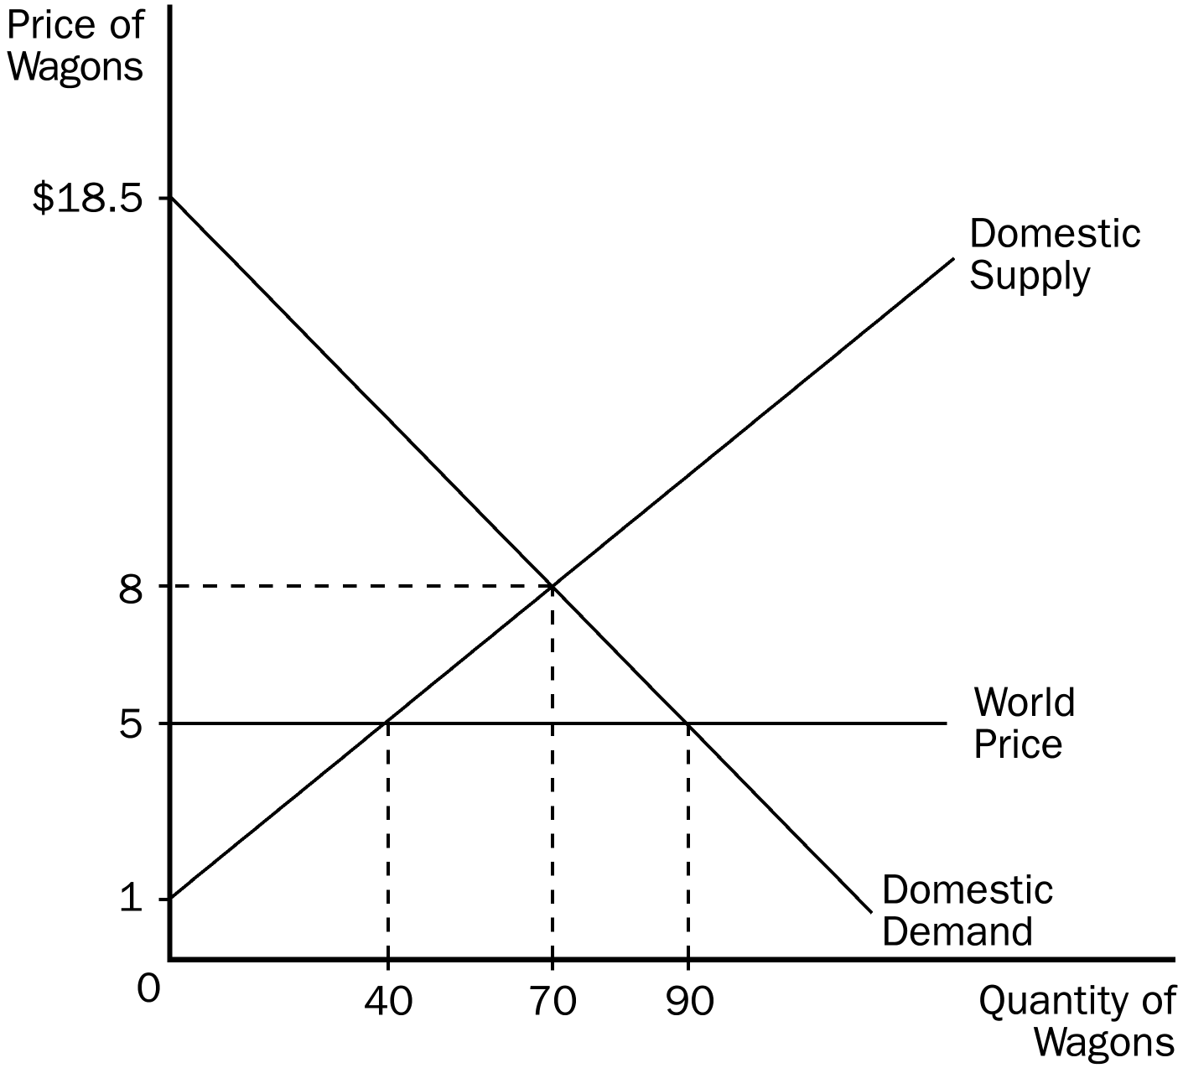
59. According to the graph, the world price for wagons represents the
a. demand for wagons from the rest of the world.
b. supply of wagons from the rest of the world.
c. level of inefficiency in the domestic market caused by trade.
d. surplus in the domestic wagon market.
ANSWER: b. supply of wagons from the rest of the world.
TYPE: M SECTION: 1 DIFFICULTY: 2
60. According to the graph, this country would
a. import 30 wagons.
b. export 20 wagons.
c. import 50 wagons.
d. export 50 wagons.
ANSWER: c. import 50 wagons.
TYPE: M SECTION: 1 DIFFICULTY: 3
61. According to the graph, without trade, consumer surplus would be
a. $210.50.
b. $245.50.
c. $367.50.
d. $607.50.
ANSWER: c. $367.50.
TYPE: M SECTION: 1 DIFFICULTY: 3
62. According to the graph, without trade, producer surplus would be
a. $210.
b. $245.
c. $450.
d. $455.
ANSWER: b. $245.
TYPE: M SECTION: 1 DIFFICULTY: 3
63. According to the graph, without trade, total surplus would be
a. $122.50.
b. $245.
c. $367.50.
d. $612.50.
ANSWER: d. $612.50.
TYPE: M SECTION: 1 DIFFICULTY: 3
64. According to the graph, if this country chooses to trade, the price of wagons in this country would be
a. $8 and 70 wagons would be sold domestically.
b. $5 and 40 wagons would be sold domestically.
c. $5 and 70 wagons would be sold domestically.
d. $5 and 90 wagons would be sold domestically.
ANSWER: d. $5 and 90 wagons would be sold domestically.
TYPE: M SECTION: 1 DIFFICULTY: 3
65. According to the graph, with free trade, consumer surplus would be
a. $245.
b. $362.50.
c. $367.50.
d. $607.50.
ANSWER: d. $607.50.
TYPE: M SECTION: 1 DIFFICULTY: 3
66. According to the graph, with free trade, producer surplus would be
a. $80.
b. $150.
c. $210.
d. $245.
ANSWER: a. $80.
TYPE: M SECTION: 1 DIFFICULTY: 3
67. According to the graph, with free trade, total surplus would be
a. $245.
b. $367.50.
c. $607.50.
d. $687.50.
ANSWER: d. $687.50.
TYPE: M SECTION: 1 DIFFICULTY: 3
68. According to the graph, with free trade, total surplus would increase by
a. $60.
b. $75.
c. $135.
d. $210.
ANSWER: b. $75.
TYPE: M SECTION: 1 DIFFICULTY: 3
69. According to the graph, the increase in total surplus resulting from trade is
a. $60. Since producer surplus increases by $180 and consumer surplus falls by $240.
b. $60. Since consumer surplus increases by $180 and producer surplus falls by $240.
c. $75. Since producer surplus increases by $240 and consumer surplus falls by $165.
d. $75. Since consumer surplus increases by $240 and producer surplus falls by $165.
ANSWER: c. $75. Since consumer surplus increases by $240 and producer surplus falls by $165.
TYPE: M SECTION: 1 DIFFICULTY: 3
70. According to the graph, if this country allows free trade in wagons,
a. consumers will gain and producers will lose.
b. consumers will lose and producers will gain.
c. both consumers and producers will gain.
d. both consumers and producers will lose.
ANSWER: a. consumers will gain and producers will lose.
TYPE: M SECTION: 1 DIFFICULTY: 2
71. According to the graph, if this country allows free trade in wagons, producers will
a. lose by $210.
b. lose by $165.
c. gain by $45.
d. gain by $210.
ANSWER: b. lose by $165.
TYPE: M SECTION: 1 DIFFICULTY: 3
72. According to the graph, if this country allows free trade in wagons, consumers will
a. lose by $75.
b. lose by $240.
c. gain by $240.
d. gain by $75.
ANSWER: c. gain by $240.
TYPE: M SECTION: 1 DIFFICULTY: 3
73. According to the graph, if this country allows free trade in wagons
a. consumers will gain more than producers will lose.
b. producers will gain more than consumers will lose.
c. producers and consumers will both gain equally.
d. producers and consumers will both lose equally.
ANSWER: a. consumers will gain more than producers will lose.
TYPE: M SECTION: 1 DIFFICULTY: 2

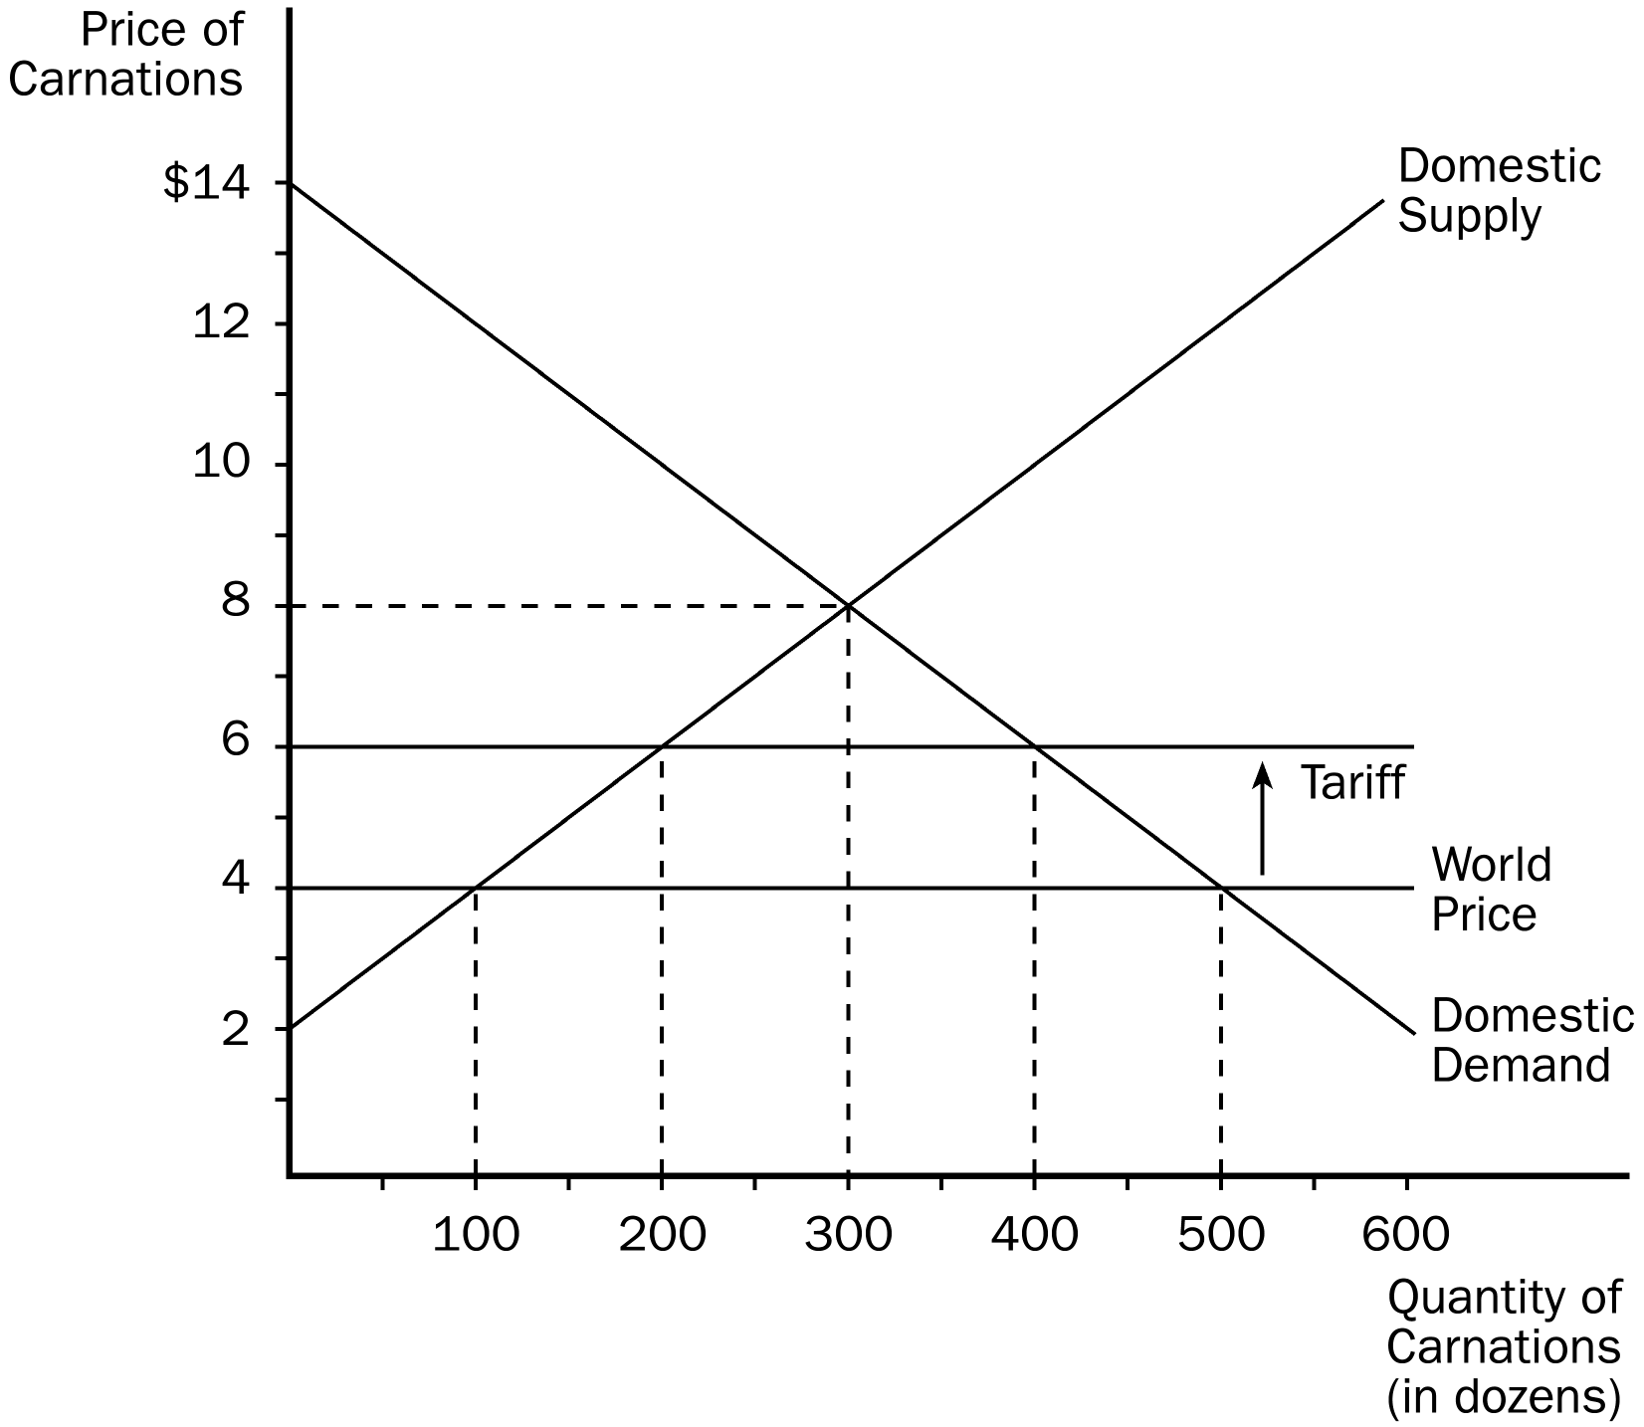

74. According to the graph, without trade, the equilibrium price of carnations would be
a. $8 and equilibrium quantity would be 300.
b. $6 and equilibrium quantity would be 200.
c. $6 and equilibrium quantity would be 400.
d. $4 and equilibrium quantity would be 500.
ANSWER: a. $8 and equilibrium quantity would be 300.
TYPE: M SECTION: 1 DIFFICULTY: 1
75. According to the graph, with free trade
a. the domestic price will equal the world price.
b. carnations will be sold at $8 in this market.
c. this country will import 200 carnations.
d. there will be a shortage of 400 carnations in this market.
ANSWER: a. the domestic price will equal the world price.
TYPE: M SECTION: 1 DIFFICULTY: 2
76. According to the graph, before the tariff is imposed, this country will
a. import 200 carnations.
b. import 400 carnations.
c. export 200 carnations.
d. export 400 carnations.
ANSWER: b. import 400 carnations.
TYPE: M SECTION: 1 DIFFICULTY: 3
77. According to the graph, the size of the tariff on carnations is
a. $2.
b. $4.
c. $6.
d. $8.
ANSWER: a. $2.
TYPE: M SECTION: 1 DIFFICULTY: 1
78. According to the graph, imposing a tariff on carnations
a. increases imports by 100.
b. increases imports by 200.
c. reduces imports by 200.
d. reduces imports by 400.
ANSWER: c. reduces imports by 200.
TYPE: M SECTION: 1 DIFFICULTY: 2
79. According to the graph, the amount of revenue collected by the government from the tariff is
a. $200.
b. $400.
c. $500.
d. $600.
ANSWER: b. $400.
TYPE: M SECTION: 1 DIFFICULTY: 2
80. According to the graph, when a tariff is imposed in the market, producers
a. gain by $100.
b. gain by $200.
c. gain by $300.
d. lose by $100.
ANSWER: c. gain by $300.
TYPE: M SECTION: 1 DIFFICULTY: 3
81. According to the graph, the amount of deadweight loss caused by the tariff equals
a. $100.
b. $200.
c. $400.
d. $500.
ANSWER: b. $200.
TYPE: M SECTION: 1 DIFFICULTY: 3
82. According to the graph, when the tariff is imposed, consumers
a. lose by $500.
b. lose by $900.
c. gain by $500.
d. gain by $900.
ANSWER: b. lose by $900.
TYPE: M SECTION: 1 DIFFICULTY: 3
83. According to the graph, before the tariff is imposed government revenue is equal to
a. $400.
b. $200.
c. $100.
d. zero.
ANSWER: d. zero.
TYPE: M SECTION: 1 DIFFICULTY: 1
84. According to the graph, if trade in shoes is allowed, Korea
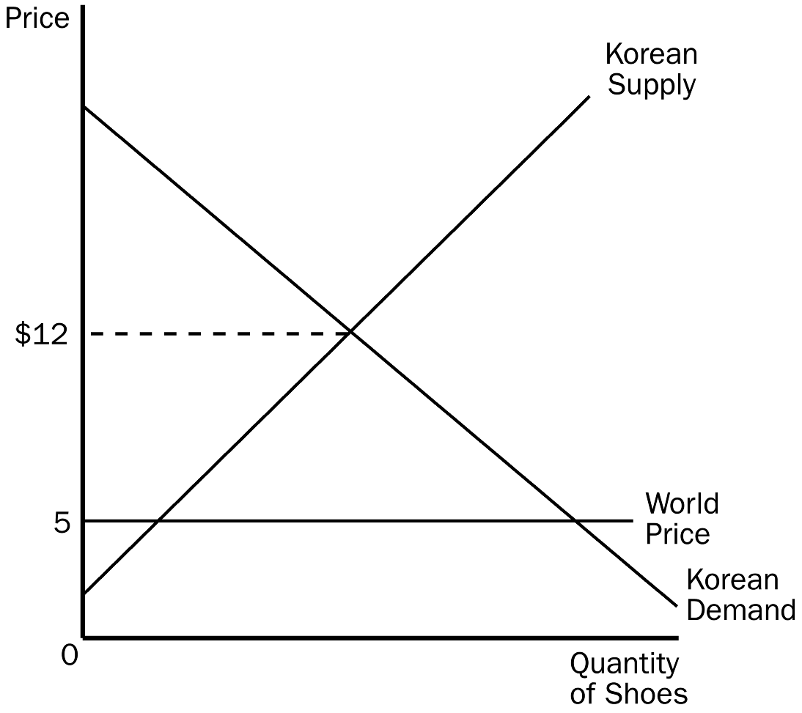
a. will become an importer of shoes.
b. will become an exporter of shoes.
c. could become either an importer of shoes or an exporter of shoes.
d. will neither import nor export shoes.
ANSWER: a. will become an importer of shoes.
TYPE: M SECTION: 2 DIFFICULTY: 2
85. According to the graph, if trade in shoes is allowed, the price of shoes in Korea will be
a. $12 per pair.
b. $5 per pair.
c. between $5 per pair and $12 per pair.
d. higher than $12 per pair.
ANSWER: b. $5 per pair.
TYPE: M SECTION: 2 DIFFICULTY:
86. According to the graph, if trade in shoes is allowed, Korean shoe
a. consumers and Korean shoe producers will gain.
b. consumers and Korean shoe producers will lose.
c. consumers will gain, and Korean shoe producers will lose.
d. producers will gain, and Korean shoe consumers will lose.
ANSWER: c. consumers will gain, and Korean shoe producers will lose.
TYPE: M SECTION: 2 DIFFICULTY: 3
87. According to the graph, if trade in shoes is allowed in Korea,
a. consumer surplus will increase and producer surplus will decrease.
b. consumer surplus will decrease and producer surplus will increase.
c. producer surplus and consumer surplus will increase.
d. producer surplus and consumer surplus will be unaffected.
ANSWER: a. consumer surplus will increase and producer surplus will decrease.
TYPE: M SECTION: 2 DIFFICULTY: 3
88. The before-trade price of fish in Greece is $3.00 per pound. The world price of fish is $5.00 per pound. Greece is a price-taker in the fish market. If Greece allows trade in fish Greece will become an
a. importer of fish and the price of fish in Greece will be $3.00.
b. importer of fish and the price of fish in Greece will be $5.00.
c. exporter of fish and the price of fish in Greece will be $3.00.
d. exporter of fish and the price of fish in Greece will be $5.00.
ANSWER: d. exporter of fish and the price of fish in Greece will be $5.00.
TYPE: M SECTION: 2 DIFFICULTY: 3
89. The before-trade price of fish in Greece is $3.00 per pound. The world price of fish is $5.00 per pound. Greece is a price-taker in the fish market. If Greece allows trade in fish, its consumers of fish will be
a. worse off and its producers of fish will be better off.
b. better off and its producers of fish will be better off.
c. worse off and its producers of fish will be worse off.
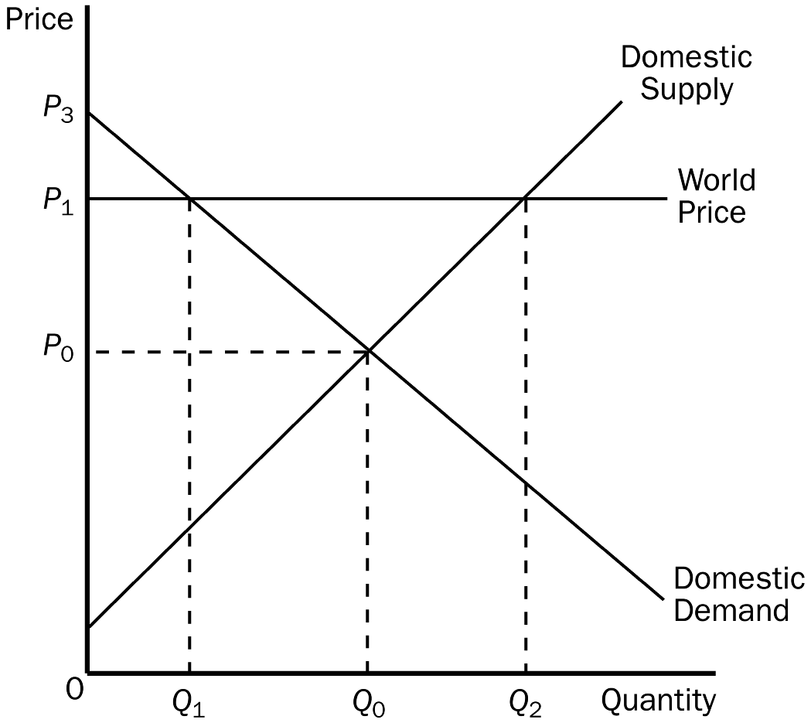
d. worse off and its producers of fish will be unaffected.
ANSWER: a. worse off and its producers of fish will be better off.
TYPE: M SECTION: 2 DIFFICULTY: 3
90. According to the graph, the equilibrium price and the equilibrium quantity of cheese in Wales before trade would be
a. P₁, Q₂.
b. P₁, Q₁.
c. P₀, Q₀.
d. P₃, 0.
ANSWER: c. P₀, Q₀.
TYPE: M SECTION: 2 DIFFICULTY: 2
91. According to the graph, the price and quantity demanded of cheese in Wales after trade would be
a. P₁, Q₂.
b. P₁, Q₁.
c. P₀, Q₀.
d. P₃, Q₁.
ANSWER: b. P₁, Q₁.
TYPE: M SECTION: 2 DIFFICULTY: 2

92. According to the graph, the quantity of cheese exported from Wales is
a. Q₀ – Q₁.
b. Q₂ – Q₁.
c. Q₂ – Q₀.
d. Q₀.
ANSWER: b. Q₂ – Q₁.
TYPE: M SECTION: 2 DIFFICULTY: 2

93. According to the graph, consumer surplus in this market before trade is
a. A.
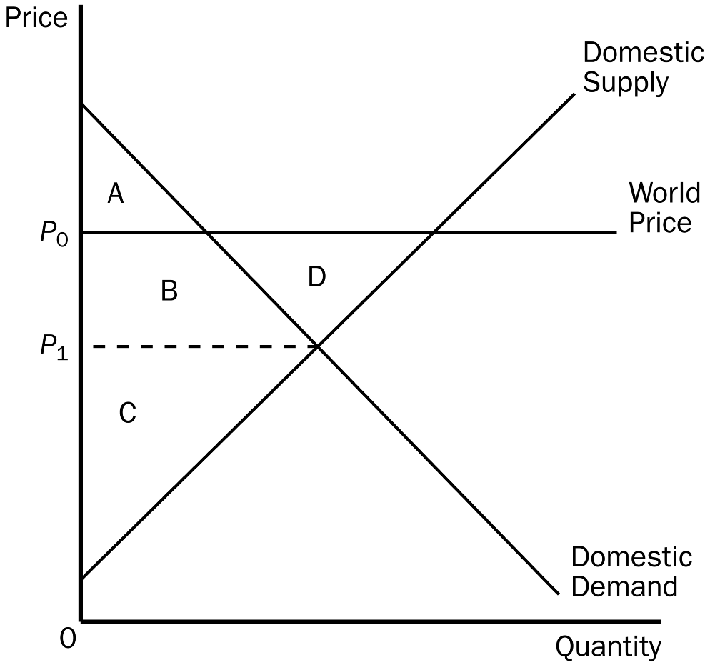
b. A + B.
c. A + B + D.
d. C.
ANSWER: b. A + B.
TYPE: M SECTION: 2 DIFFICULTY: 2
94. According to the graph, consumer surplus in this market after trade is
a. A.
b. A + B.
c. A + B + D.
d. C.
ANSWER: a. A.
TYPE: M SECTION: 2 DIFFICULTY: 2
95. According to the graph, producer surplus in this market before trade is
a. A.
b. A + B.
c. C + B + D.
d. C.
ANSWER: d. C.
TYPE: M SECTION: 2 DIFFICULTY: 2
96. According to the graph, producer surplus in this market after trade is
a. A.
b. A + B.
c. C + B + D.
d. C.
ANSWER: c. C + B + D.
TYPE: M SECTION: 2 DIFFICULTY: 2
97. According to the graph, total surplus in this market before trade is
a. A + B.
b. A + B + C.
c. A + B + C + D.
d. B + C + D.
ANSWER: b. A + B + C.
TYPE: M SECTION: 2 DIFFICULTY: 2
98. According to the graph, total surplus in this market after trade is
a. A + B.
b. A + B + C.
c. A + B + C + D.
d. B + C + D.
ANSWER: c. A + B + C + D.
TYPE: M SECTION: 2 DIFFICULTY: 2
99. According to the graph, the change in total surplus in this market because of trade is
a. A.
b. B.
c. C.
d. D.
ANSWER: d. D.
TYPE: M SECTION: 2 DIFFICULTY: 2
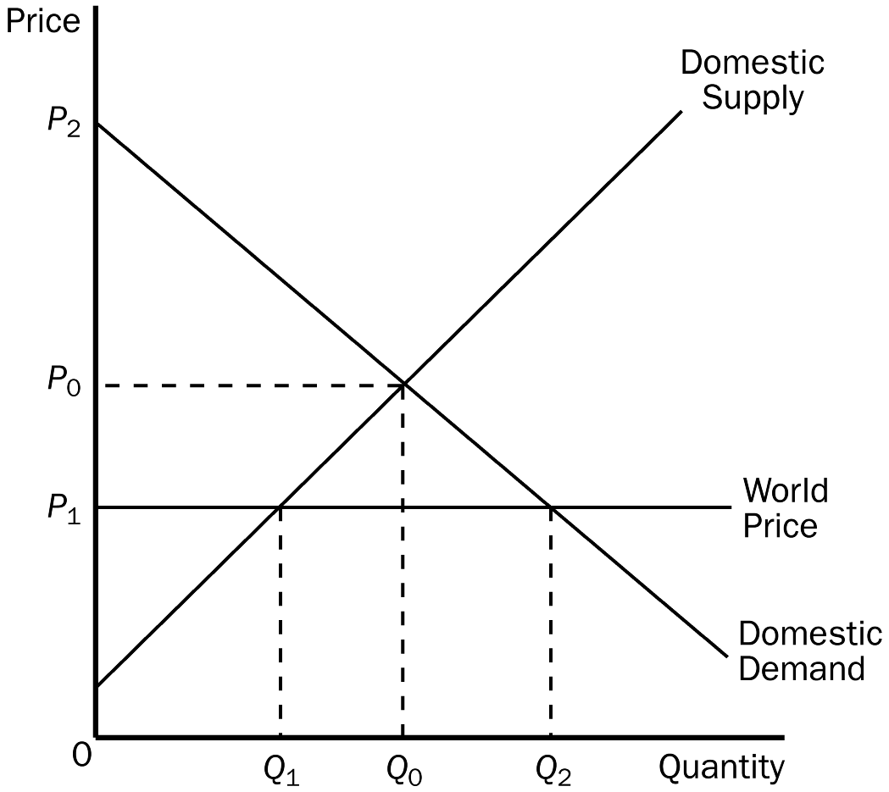
100. According to the graph, the price and quantity of air conditioners in Kenya before trade would be
a. P₀, Q₀.
b. P₁, Q₁.
c. P₂, Q₂.
d. P₁, Q₀.
ANSWER: a. P₀, Q₀.
TYPE: M SECTION: 2 DIFFICULTY: 2
101. According to the graph, the price of air conditioners and the quantity demanded in Kenya after trade would be
a. P₁, Q₁.
b. P₁, Q₂.
c. P₂, Q₂.
d. P₀, Q₀.
ANSWER: b. P₁, Q₂.
TYPE: M SECTION: 2 DIFFICULTY: 2
102. According to the graph, the quantity of air conditioners imported into Kenya is
a. Q₀.
b. Q₁.
c. Q₂.
d. Q₂ – Q₁.
ANSWER: d. Q₂ – Q₁.
TYPE: M SECTION: 2 DIFFICULTY: 2
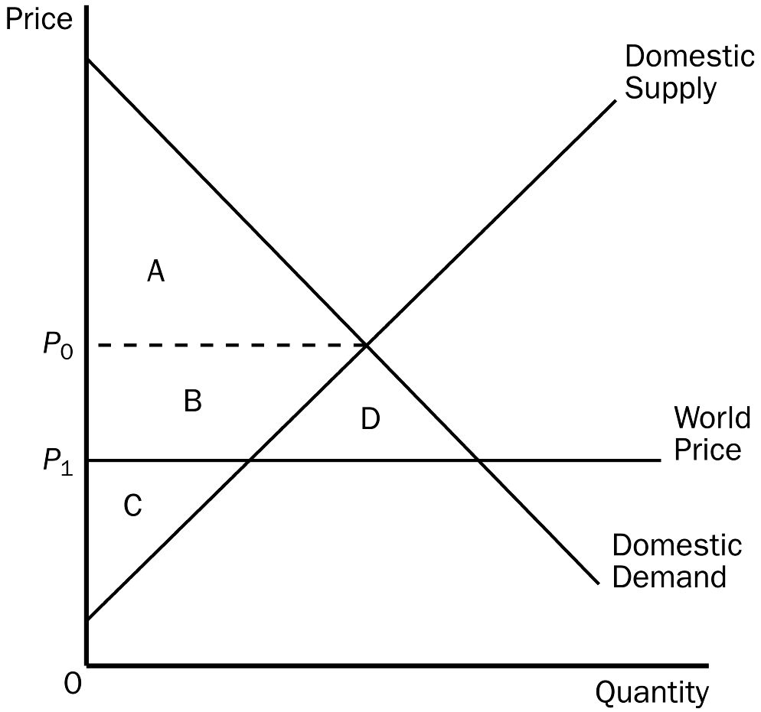
103. According to the graph, consumer surplus in this market before trade would be
a. A.
b. B + C.
c. A + B + D.
d. C.
ANSWER: a. A.
TYPE: M SECTION: 2 DIFFICULTY: 2
104. According to the graph, consumer surplus in this market after trade would be
a. A.
b. C + B.
c. A + B + D.
d. B + C + D.
ANSWER: c. A + B + D.
TYPE: M SECTION: 2 DIFFICULTY: 2
105. According to the graph, producer surplus in this market before trade would be
a. C.
b. B + C.
c. A + B + D.
d. B + C + D.
ANSWER: b. B + C.
TYPE: M SECTION: 2 DIFFICULTY: 2
106. According to the graph, producer surplus in this market after trade would be
a. C.
b. C + B.
c. A + B + D.
d. B + C + D.
ANSWER: a. C.
TYPE: M SECTION: 2 DIFFICULTY: 2
107. According to the graph, producer surplus plus consumer surplus in this market before trade is
a. A + B.
b. A + B + C.
c. A + B + C + D.
d. B + C + D.
ANSWER: b. A + B + C.
TYPE: M SECTION: 2 DIFFICULTY: 2
108. According to the graph, producer surplus plus consumer surplus in this market after trade is
a. A + B.
b. A + B + C.
c. A + B + C + D.
d. B + C + D.
ANSWER: c. A + B + C + D.
TYPE: M SECTION: 2 DIFFICULTY: 2
109. According to the graph, the change in total surplus in this market because of trade is
a. A.
b. B.
c. C.
d. D.
ANSWER: d. D.
TYPE: M SECTION: 2 DIFFICULTY: 2
110. According to the graph, equilibrium price and quantity before trade would be
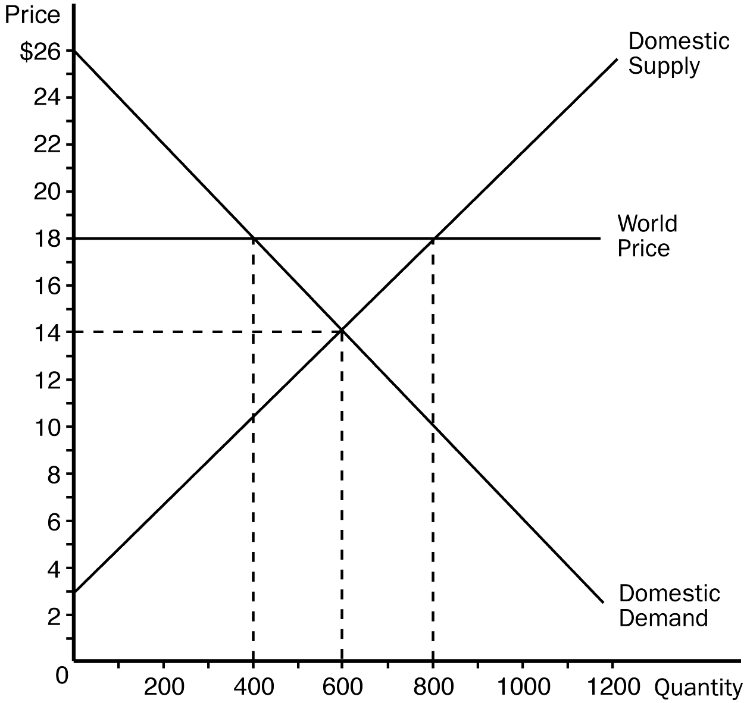
a. $18 and 400.
b. $18 and 800.
c. $14 and 400.
d. $14 and 600.
ANSWER: d. $14 and 600.
TYPE: M SECTION: 2 DIFFICULTY: 2
111. According to the graph, the price and domestic quantity demanded after trade would be
a. $18 and 400.
b. $18 and 800.
c. $14 and 400.
d. $14 and 600.
ANSWER: a. $18 and 400.
TYPE: M SECTION: 2 DIFFICULTY: 2
112. According to the graph, after trade domestic production and domestic consumption, respectively, would be
a. 600 and 400.
b. 800 and 400.
c. 400 and 600.
d. 400 and 800.
ANSWER: b. 800 and 400.
TYPE: M SECTION: 2 DIFFICULTY: 2
113. According to the graph, consumer surplus before trade would be
a. $1600.
b. $2400.
c. $3200.
d. $3600.
ANSWER: d. $3600.
TYPE: M SECTION: 2 DIFFICULTY: 2
114. According to the graph, consumer surplus after trade would be
a. $1600.
b. $2400.
c. $3200.
d. $3600.
ANSWER: a. $1600.
TYPE: M SECTION: 2 DIFFICULTY: 2
115. According to the graph, producer surplus before trade would be
a. $3600.
b. $4400.
c. $5200.
d. $6600.
ANSWER: a. $3600.
TYPE: M SECTION: 2 DIFFICULTY: 2
116. According to the graph, producer surplus after trade would be
a. $4800.
b. $5600.
c. $6400.
d. $7000.
ANSWER: c. $6400.
TYPE: M SECTION: 2 DIFFICULTY: 2
117. According to the graph, how many units of this product would be exported after trade is allowed?
a. 200
b. 400
c. 600
d. 800
ANSWER: b. 400
TYPE: M SECTION: 2 DIFFICULTY: 2
118. According to the graph, equilibrium price and quantity before trade would be
a. $8 and 300.
b. $8 and 900.
c. $14 and 300.
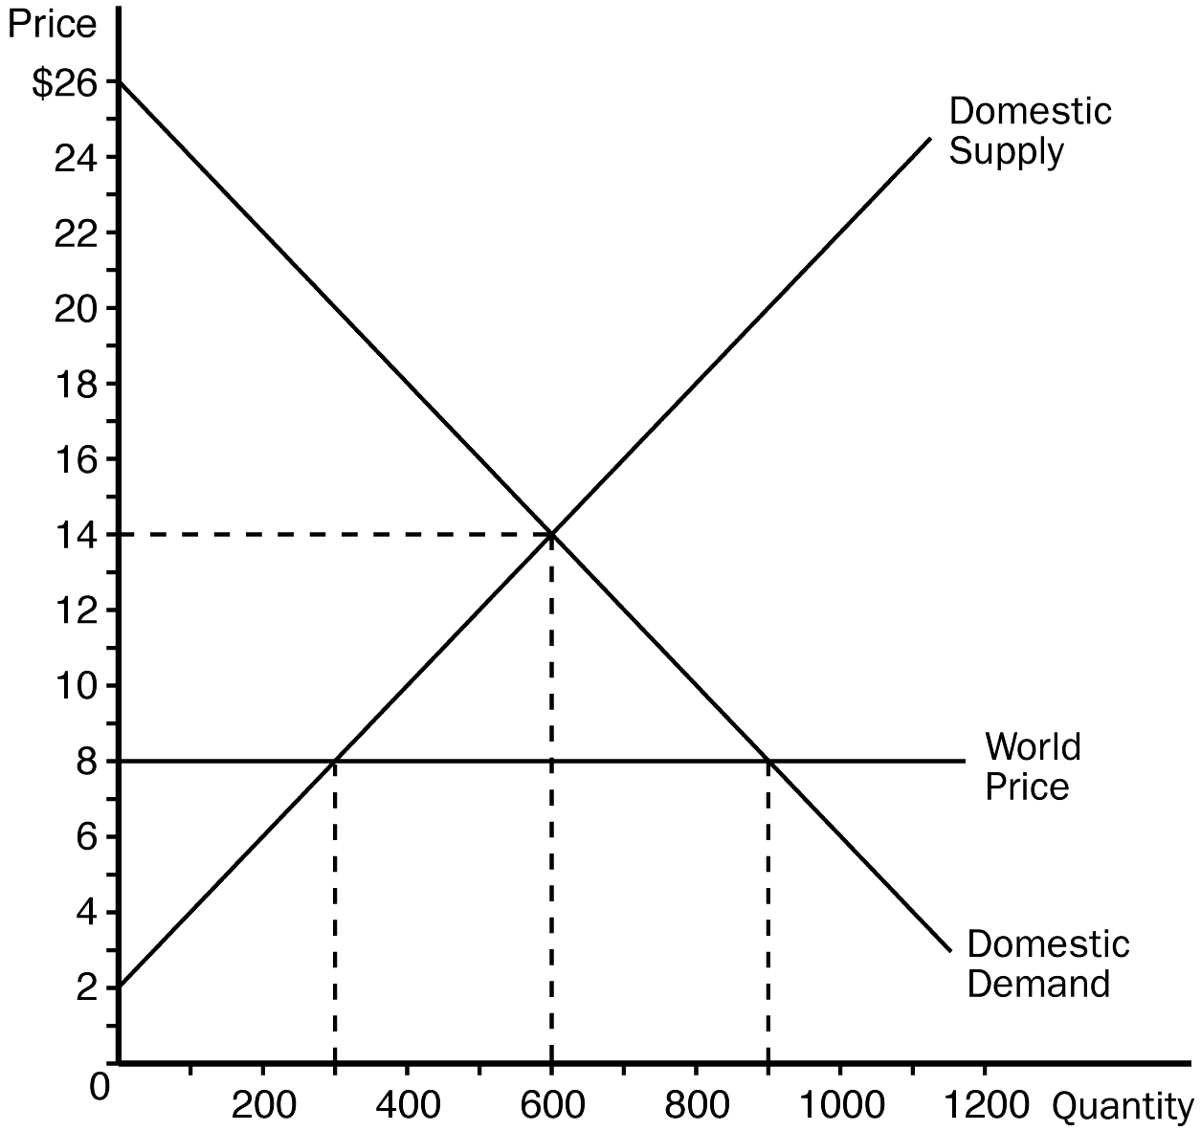
d. $14 and 600.
ANSWER: d. $14 and 600.
TYPE: M SECTION: 2 DIFFICULTY: 2
119. According to the graph, the price and domestic quantity demanded after trade would be
a. $8 and 300.
b. $8 and 900.
c. $14 and 900.
d. $14 and 600.
ANSWER: b. $8 and 900.
TYPE: M SECTION: 2 DIFFICULTY: 2
120. According to the graph, domestic production and domestic consumption respectively after trade would be
a. 600 and 600.
b. 600 and 300.
c. 300 and 900.
d. 600 and 900.
ANSWER: c. 300 and 900.
TYPE: M SECTION: 2 DIFFICULTY: 2
121. According to the graph, consumer surplus before trade would be
a. $1600.
b. $2400.
c. $3200.
d. $3600.
ANSWER: d. $3600.
TYPE: M SECTION: 2 DIFFICULTY: 2
122. According to the graph, consumer surplus after trade would be
a. $3600.
b. $5400.
c. $7200.
d. $8100.
ANSWER: d. $8100.
TYPE: M SECTION: 2 DIFFICULTY: 2
123. According to the graph, producer surplus before trade would be
a. $3600.
b. $4400.
c. $5200.
d. $6600.
ANSWER: a. $3600.
TYPE: M SECTION: 2 DIFFICULTY: 2
124. According to the graph, producer surplus after trade would be
a. $900.
b. $1100.
c. $1500.
d. $2000.
ANSWER: a. $900.
TYPE: M SECTION: 2 DIFFICULTY: 2
125. According to the graph, how many units of this product would be imported after trade?
a. 200
b. 400
c. 600
d. 800
ANSWER: c. 600
TYPE: M SECTION: 2 DIFFICULTY: 2
126. A tariff on a product makes domestic sellers
a. better off and domestic buyers worse off.
b. worse off and domestic buyers worse off.
c. better off and domestic buyers better off.
d. worse off and domestic buyers better off.
ANSWER: a. better off and domestic buyers worse off.
TYPE: M SECTION: 2 DIFFICULTY: 2
127. A tariff is
a. a tax on imported goods.
b. a tax on exported goods.
c. a limit on imported goods.
d. a tax on luxuries.
ANSWER: a. a tax on imported goods.
TYPE: M SECTION: 2 DIFFICULTY: 1
128. A tariff is a tax placed on
a. exported goods that lowers the domestic price below the world price.
b. exported goods that keeps the domestic price the same as the world price.
c. imported goods that lowers the domestic price below the world price.
d. imported goods that raises the domestic price above the world price.
ANSWER: d. imported goods that raises the domestic price above the world price.
TYPE: M SECTION: 2 DIFFICULTY: 3
129. A tariff
a. lowers the price of the exported good below the world price.
b. keeps the price of the exported good the same as the world price.
c. raises the price of the imported good above the world price.
d. lowers the price of the imported good below the world price.
ANSWER: c. raises the price of the imported good above the world price.
TYPE: M SECTION: 2 DIFFICULTY: 2
130. When a country moves from a free trade position and imposes a tariff on imports, this causes
a. a decrease in total surplus in the market.
b. a decrease in producer surplus in the market.
c. an increase in consumer surplus in the market.
d. a decrease in revenue to the government.
ANSWER: a. a decrease in total surplus in the market.
TYPE: M SECTION: 2 DIFFICULTY: 2
131. When President Bush imposed a tariff on imported steel, economists estimated it would
a. cause the price of steel to increase by as much as 10 percent.
b. cause the price of steel to increase by as much as 25 percent.
c. start trade wars with our trading partners.
d. cause the United States to export more steel.
ANSWER: a. cause the price of steel to increase by as much as 10 percent.
TYPE: M SECTION: 2 DIFFICULTY: 1
132. Denmark is an importer of computer chips and is also a price-taker in the chip market. The world price of these computer chips is $12. If Denmark imposes a $5 tariff on chips, the result in Denmark would be that the price of computer chips will be
a. $17 and the quantity purchased will fall.
b. $12 and the quantity purchased will fall.
c. $7 and the quantity purchased will increase.
d. $17 and the quantity purchased will increase.
ANSWER: a. $17 and the quantity purchased will fall.
TYPE: M SECTION: 2 DIFFICULTY: 3
133. Denmark is an importer of computer chips and is also a price-taker in the chip market. The world price of these computer chips is $12. If Denmark imposes a $5 tariff on chips, the result in Denmark would be that consumers
a. and producers will both gain.
b. and producers will both lose.
c. will gain and producers will lose.
d. will lose and producers will gain.
ANSWER: d. will lose and producers will gain.
TYPE: M SECTION: 2 DIFFICULTY: 2
134. Turkey is an importer of goose down pillows. The world price of these pillows is $50. Turkey imposes a $7 tariff on pillows. Turkey is a price-taker in the pillow market. As a result of the tariff Turkey’s price of pillows will be
a. $50 and the quantity of pillows purchased will decrease.
b. $57 and the quantity of pillows purchased will decrease.
c. $50 and the quantity of pillows purchased will increase.
d. $57 and the quantity of pillows purchased will increase.
ANSWER: b. $57 and the quantity of pillows purchased will decrease.
TYPE: M SECTION: 2 DIFFICULTY: 3
135. Turkey is an importer of goose down pillows. The world price of these pillows is $50. Turkey imposes a $7 tariff on pillows. Turkey is a price-taker in the pillow market. As a result of the tariff Turkish consumers of pillows will
a. gain and Turkish producers of pillows will lose.
b. lose and Turkish producers of pillows will gain.
c. gain and Turkish producers of pillows will gain.
d. lose and Turkish producers of pillows will lose.
ANSWER: b. lose and Turkish producers of pillows will gain.
TYPE: M SECTION: 2 DIFFICULTY: 2
136. In 2000, India raised the tariff on
a. American chicken legs from 35 percent to 100 percent.
b. American chicken legs from 25 percent to 50 percent.
c. American steel from 50 percent to 100 percent.
d. American steel from 25 percent to 50 percent.
ANSWER: a. American chicken legs from 35 percent to 100 percent.
TYPE: M SECTION: 2 DIFFICULTY: 1
137. Trade in chicken between the United States and India would be advantageous for both countries since
a. Americans prefer the white meat and Indians prefer the dark meat.
b. the United States has a comparative advantage in chicken and India has an absolute advantage in chicken.
c. there are no trade barriers between the United States and India.
d. the United States produces more chicken each year than is needed in the domestic chicken market.
ANSWER: a. Americans prefer the white meat and Indians prefer the dark meat.
TYPE: M SECTION: 2 DIFFICULTY: 2
138. In the figure shown, the free-trade price and domestic quantity demanded would be
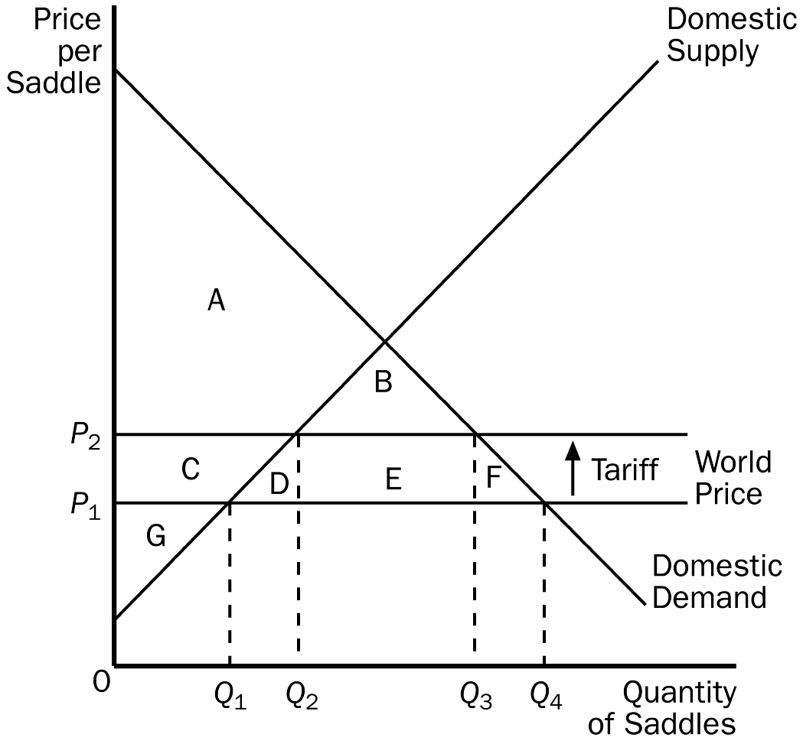
a. P₁, Q₁.
b. P₁, Q₄.
c. P₂, Q₂.
d. P₂, Q₃.
ANSWER: b. P₁, Q₄.
TYPE: M SECTION: 2 DIFFICULTY: 2
139. In the figure shown, the domestic price and domestic quantity demanded after the tariff would be
a. P₁, Q₁.
b. P₁, Q₄.
c. P₂, Q₂.
d. P₂, Q₃.
ANSWER: d. P₂, Q₃.
TYPE: M SECTION: 2 DIFFICULTY: 2
140. In the figure shown, consumer surplus with free trade would be
a. A.
b. A + B.
c. A + C + G.
d. A + B + C + D + E + F.
ANSWER: d. A + B + C + D + E + F.
TYPE: M SECTION: 2 DIFFICULTY: 2
141. In the figure shown, producer surplus with free trade would be
a. G.
b. C + G.
c. A + C + G.
d. A + B + C + G.
ANSWER: a. G.
TYPE: M SECTION: 2 DIFFICULTY: 2
142. In the figure shown, consumer surplus after the tariff would be
a. A.
b. A + B.
c. A + C + G.
d. A + B + C + D +E + F.
ANSWER: b. A + B.
TYPE: M SECTION: 2 DIFFICULTY: 2
143. In the figure shown, producer surplus after the tariff would be
a. G.
b. C + G.
c. A + C + G.
d. A + B + C + G.
ANSWER: b. C + G.
TYPE: M SECTION: 2 DIFFICULTY: 2
144. In the figure shown, as a result of the tariff, government revenue would be
a. E.
b. B.
c. D + F.
d. B + D + E + F.
ANSWER: a. E.
TYPE: M SECTION: 2 DIFFICULTY: 2
145. In the figure shown, as a result of the tariff, deadweight loss would be
a. E.
b. B.
c. D + F.
d. B + D + E + F.
ANSWER: c. D + F.
TYPE: M SECTION: 2 DIFFICULTY: 2
146. A quota is
a. a tax placed on imports.
b. a limit on the quantity of imports.
c. a tax on exports to other countries.
d. an excess of exports over imports.
ANSWER: b. a limit on the quantity of imports.
TYPE: M SECTION: 2 DIFFICULTY: 1
147. When a quota is imposed on a market the
a. supply curve (above the world price) shifts to the right by the amount of the quota.
b. supply curve (above the world price) shifts to the left by the amount of the quota.
c. demand curve (above the world price) shifts to the right by the amount of the quota.
d. demand curve (above the world price) shifts to the left by the amount of the quota.
ANSWER: a. supply curve (above the world price) shifts to the right by the amount of the quota.
TYPE: M SECTION: 2 DIFFICULTY: 2
148. A tariff and an import quota will both
a. increase the quantity of imports and raise domestic price.
b. increase the quantity of imports and lower domestic price.
c. reduce the quantity of imports and raise domestic price.
d. reduce the quantity of imports and lower domestic price.
ANSWER: c. reduce the quantity of imports and raise domestic price.
TYPE: M SECTION: 2 DIFFICULTY: 3
149. According to the graph, without trade, the price of birdhouses in this market is
a. $4 and quantity sold in 100.
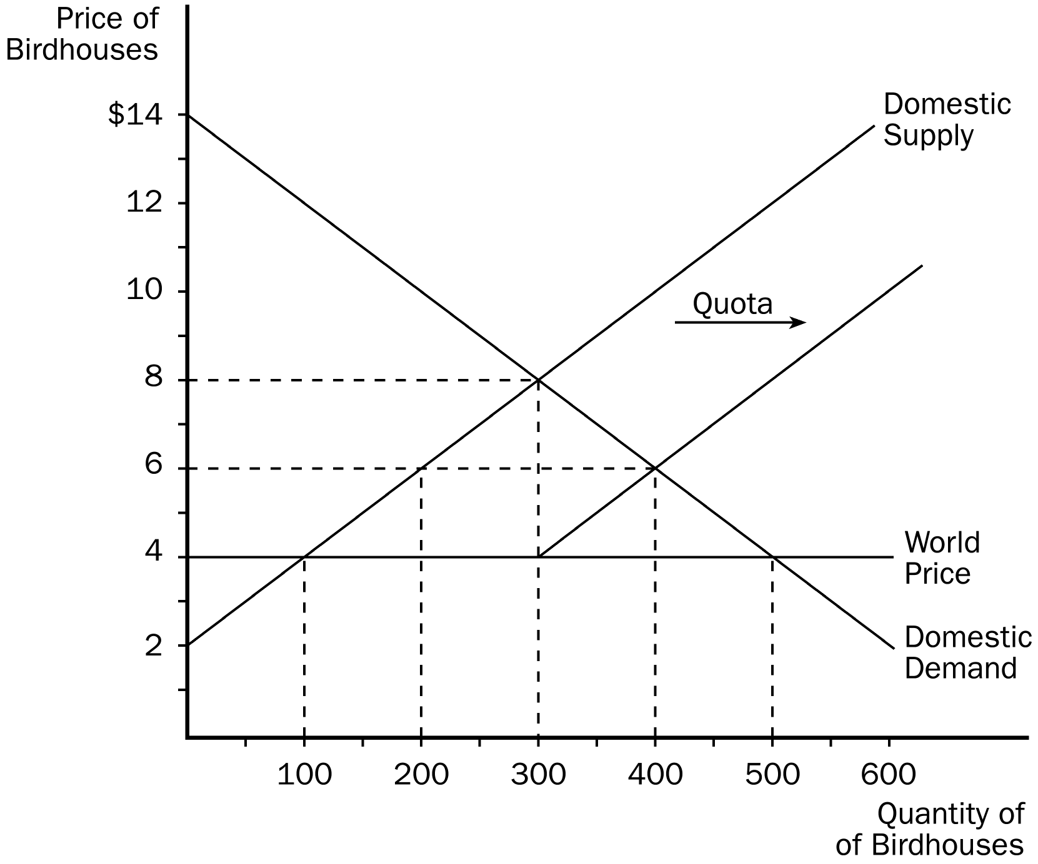
b. $6 and quantity sold is 200.
c. $6 and quantity sold is 400.
d. $8 and quantity sold is 300.
ANSWER: d. $8 and quantity sold is 300.
TYPE: M SECTION: 2 DIFFICULTY: 2
150. According to the graph, with free trade, the price of birdhouses would be
a. $4 and quantity sold would be 500.
b. $4 and quantity sold would be 100.
c. $6 and quantity sold would be 400.
d. $8 and quantity sold would be 300.
ANSWER: a. $4 and quantity sold would be 500.
TYPE: M SECTION: 2 DIFFICULTY: 3
151. According to the graph, after the quota is imposed price would be
a. $8 and quantity sold would be 300.
b. $6 and quantity sold would be 200.
c. $6 and quantity sold would be 400.
d. $4 and quantity sold would be 300.
ANSWER: c. $6 and quantity sold would be 400.
TYPE: M SECTION: 2 DIFFICULTY: 3
152. According to the graph, the amount of the quota is
a. 100 birdhouses.
b. 200 birdhouses.
c. 300 birdhouses.
d. 400 birdhouses.
ANSWER: b. 200 birdhouses.
TYPE: M SECTION: 2 DIFFICULTY: 2
153. According to the graph, the deadweight loss as a result of the quota would be
a. $100.
b. $200.
c. $400.
d. $500.
ANSWER: b. $200.
TYPE: M SECTION: 2 DIFFICULTY: 3
154. According to the graph, as a result of the quota, domestic producer surplus increases by
a. $100.
b. $200.
c. $300.
d. $400.
ANSWER: c. $300.
TYPE: M SECTION: 2 DIFFICULTY: 3
155. According to the graph, the gain as a result of the quota to license holders who import birdhouses would be
a. $100.
b. $200.
c. $400.
d. $500.
ANSWER: c. $400.
TYPE: M SECTION: 2 DIFFICULTY: 3
156. According to the graph, as a result of the quota consumer surplus falls by
a. $200.
b. $300.
c. $500.
d. $900.
ANSWER: d. $900.
TYPE: M SECTION: 2 DIFFICULTY: 3
157. According to the graph, the loss in total surplus when the quota is imposed would be
a. $100.
b. $200.
c. $400.
d. $500.
ANSWER: b. $200.
TYPE: M SECTION: 2 DIFFICULTY: 2
158. In the figure shown, the free-trade price and domestic quantity demanded would be
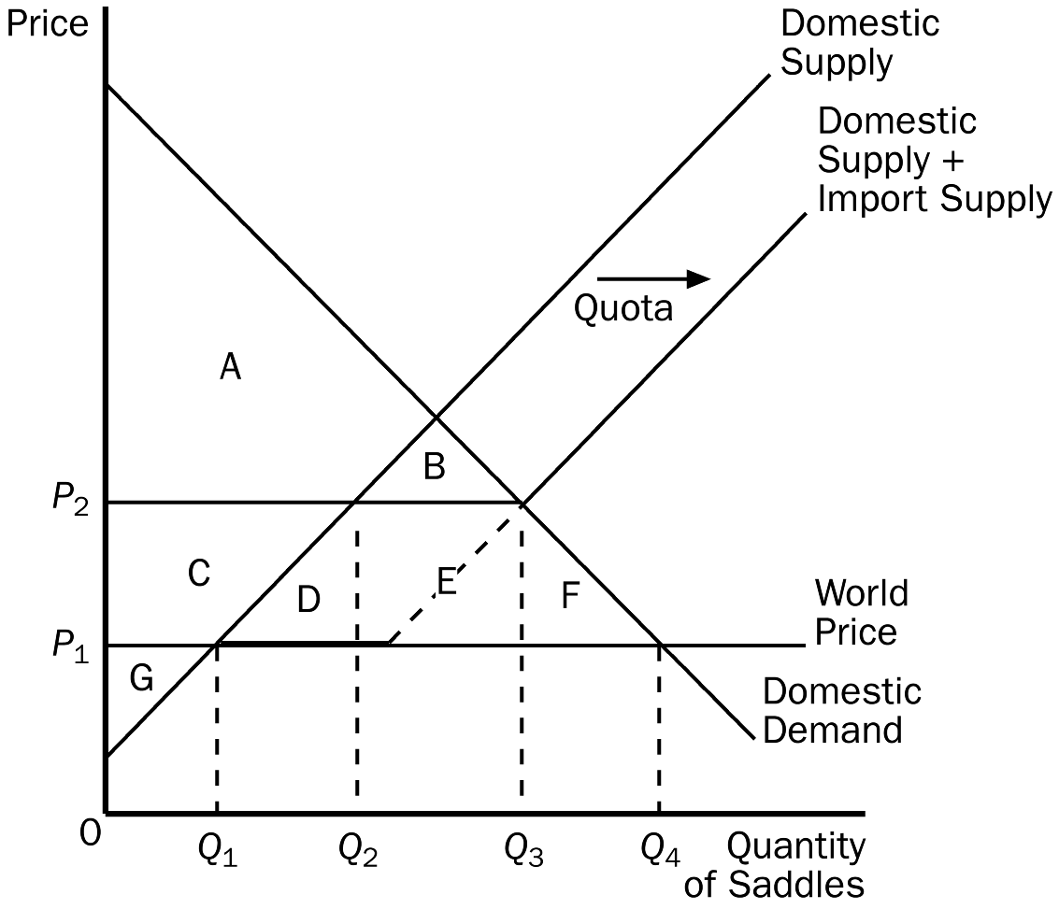
a. P₁ and Q₁.
b. P₁ and Q₄.
c. P₂ and Q₂.
d. P₂ and Q₃.
ANSWER: b. P₁ and Q₄.
TYPE: M SECTION: 2 DIFFICULTY: 2
159. In the figure shown, the equilibrium price and quantity after the quota would be
a. P₁ and Q₁.
b. P₁ and Q_{4.}
c. P₂ and Q₂.
d. P₂ and Q₃.
ANSWER: d. P₂ and Q₃.
TYPE: M SECTION: 2 DIFFICULTY: 2
160. In the figure shown, after the quota, imports would be equal to
a. Q₄ – Q₁.
b. Q₃ – Q₂.
c. Q₃ – Q₁.
d. Q₂ – Q₁.
ANSWER: b. Q₃ – Q₂.
TYPE: M SECTION: 2 DIFFICULTY: 2
161. In the figure shown, after the quota, deadweight loss would be equal to
a. E.
b. B.
c. D + F.
d. B + D + E + F.
ANSWER: c. D + F.
TYPE: M SECTION: 2 DIFFICULTY: 2
162. In the figure shown, area E represents
a. a part of consumer surplus.
b. a part of producer surplus.
c. a surplus for import license holders.
d. government revenue.
ANSWER: c. a surplus for import license holders.
TYPE: M SECTION: 2 DIFFICULTY: 2
163. The major difference between tariffs and import quotas is that
a. tariffs create deadweight losses, but import quotas do not.
b. tariffs help domestic consumers, and import quotas help domestic producers.
c. tariffs raise revenue for the government, but import quotas create a surplus for import license holders.
d. All of the above are correct.
ANSWER: c. tariffs raise revenue for the government, but import quotas create a surplus for import license holders.
TYPE: M SECTION: 2 DIFFICULTY: 2
164. Import quotas and tariffs have each of the following in common EXCEPT
a. the domestic price of the good increases.
b. consumer surplus increases.
c. producer surplus increases.
d. deadweight losses occur.
ANSWER: b. consumer surplus increases.
TYPE: M SECTION: 2 DIFFICULTY: 2
165. Import quotas and tariffs have each of the following in common EXCEPT
a. total surplus falls.
b. deadweight losses occur.
c. producer surplus increases.
d. revenue to government is raised.
ANSWER: d. revenue to government is raised.
TYPE: M SECTION: 2 DIFFICULTY: 2
166. Which of the following is an argument for restricting trade?
a. Trade restrictions make all Americans better off.
b. Trade restrictions increase economic efficiency.
c. Trade restrictions are necessary for economic growth.
d. Trade restrictions are sometimes necessary for national security.
ANSWER: d. Trade restrictions are sometimes necessary for national security.
TYPE: M SECTION: 3 DIFFICULTY: 2
167. Which of the following is NOT an argument for restricting trade?
a. the jobs argument
b. the national security argument
c. the infant industry argument
d. the efficiency argument
ANSWER: d. the efficiency argument
TYPE: M SECTION: 3 DIFFICULTY: 1
168. Workers displaced by trade will eventually find jobs in
a. another country.
b. the government sector.
c. the industries in which the country has a comparative advantage.
d. a different company in the same industry.
ANSWER: c. the industries in which the country has a comparative advantage.
TYPE: M SECTION: 3 DIFFICULTY: 1
169. The infant industry argument
a. is based on the belief that protecting industries when they are young will pay off later.
b. is based on the belief that protecting industries producing goods and services for infants is necessary if a country is to have healthy children.
c. has the support of most economists.
d. has proven to be correct in nearly all cases.
ANSWER: a. is based on the belief that protecting industries when they are young will pay off later.
TYPE: M SECTION: 3 DIFFICULTY: 1
170. Which of the following is the most accurate statement?
a. Protection is necessary in order for young industries to grow up and be successful.
b. Protection is not necessary for an industry to grow.
c. Protection is necessary because if young industries are not protected, they may suffer losses.
d. Protection may not always be necessary for infant industries, but it has proven to be useful in most cases.
ANSWER: b. Protection is not necessary for an industry to grow.
TYPE: M SECTION: 3 DIFFICULTY: 2
171. If the Japanese steel industry subsidizes the steel that it sells to the United States, the
a. United States should protect its domestic steel industry from this unfair competition.
b. harm done to U.S. steel producers from this unfair competition exceeds the gain to U.S. consumers of cheap Japanese steel.
c. harm done to U.S. steel producers is less than the benefit to U.S. consumers of steel.
d. United States should subsidize the products it sells to Japan.
ANSWER: c. harm done to U.S. steel producers is less than the benefit to U.S. consumers of steel.
TYPE: M SECTION: 3 DIFFICULTY: 2
172. If the United States threatens to impose a tariff on German cars if Germany does not remove agricultural subsidies, the United States will be
a. better off no matter how Germany responds.
b. better off if Germany gives in, and will be no worse off if it doesn’t.
c. worse off if Germany doesn’t give in to the threat.
d. worse off no matter how Germany responds.
ANSWER: c. worse off if Germany doesn’t give in to the threat.
TYPE: M SECTION: 3 DIFFICULTY: 2
173. When a country takes a multilateral approach to free trade it
a. removes trade restrictions on its own.
b. reduces its trade restrictions while other countries do the same.
c. does not remove trade restrictions no matter what other countries do.
d. is willing to trade with multiple countries at once.
ANSWER: b. reduces its trade restrictions while other countries do the same.
TYPE: M SECTION: 3 DIFFICULTY: 1
174. When a country takes a unilateral approach to free trade it
a. removes trade restrictions on its own.
b. reduces its trade restrictions while other countries do the same.
c. does not remove trade restrictions no matter what other countries do.
d. is willing to trade with multiple countries at once.
ANSWER: a. it removes trade restrictions on its own.
TYPE: M SECTION: 3 DIFFICULTY: 1
175. Which of the following is NOT true about the multilateral approach to free trade?
a. The multilateral approach has the potential to result in freer trade than does the unilateral approach.
b. The multilateral approach may have a political advantage over the unilateral approach.
c. The multilateral approach is simpler than the unilateral approach.
d. NAFTA and GATT are both multilateral approaches to free trade.
ANSWER: c. The multilateral approach is simpler than the unilateral approach.
TYPE: M SECTION: 3 DIFFICULTY: 2
176. Which of the following is NOT an advantage to a multilateral approach to free trade over a unilateral approach?
a. A multilateral approach can reduce trade restrictions abroad as well as at home.
b. A multilateral approach has the potential to result in freer trade.
c. A multilateral approach requires the agreement of 2 or more nations.
d. A multilateral approache may have political advantages.
ANSWER: c. A multilateral approach requires the agreement of 2 or more nations.
TYPE: M SECTION: 3 DIFFICULTY: 2
177. Since World War II, GATT has been responsible for reducing the average tariff among member countries from about
a. 40 percent to about 5 percent.
b. 40 percent to about 20 percent.
c. 80 percent to about 20 percent.
d. 20 percent to about 10 percent.
ANSWER: a. 40 percent to about 5 percent.
TYPE: M SECTION: 3 DIFFICULTY: 1
178. One result of the GATT trade agreement is that since World War II
a. average tariffs among member countries has fallen from 40 percent to about 5 percent.
b. quotas among member countries have been eliminated.
c. member countries have eliminated all trade restrictions.
d. Both a and b are correct.
ANSWER: a. average tariffs among member countries has fallen from 40 percent to about 5 percent.
TYPE: M SECTION: 3 DIFFICULTY: 1
179. The North American Free Trade Agreement
a. increased trade restrictions among Canada, Mexico and the United States
b. eliminated tariffs on imports to North America from the rest of the world.
c. reduced trade restrictions among Canada, Mexico and the United States
d. None of the above are correct.
ANSWER: c. reduced trade restrictions among Canada, Mexico and the United States
TYPE: M SECTION: 3 DIFFICULTY: 1
180. What percent of total world trade do World Trade Organization countries make up?
a. 54 percent
b. 72 percent
c. 89 percent
d. 97 percent
ANSWER: d. 97 percent
TYPE: M SECTION: 3 DIFFICULTY: 1
181. Economists and the public
a. often disagree about free trade.
b. always agree about free trade.
c. always disagree about free trade.
d. seldom disagree about free trade.
ANSWER: a. often disagree about free trade.
TYPE: M SECTION: 4 DIFFICULTY: 1
182. At present, the United States uses a system of quotas to limit the amount of sugar imported into the country. Which of the following statements is most likely to be true?
a. The quotas are probably the result of lobbying from U.S. consumers of sugar. The quotas increase consumer surplus for the United States, reduce producer surplus for the United States and harm foreign sugar producers.
b. The quotas are probably the result of lobbying from U.S. producers of sugar. The quotas increase producer surplus for the United States, reduce consumer surplus for the United States and harm foreign sugar producers.
c. The quotas are probably the result of lobbying from foreign producers of sugar. The quotas reduce producer surplus for the United States, increase consumer surplus for the United States and benefit foreign sugar producers.
d. U.S. lawmakers did not need to be lobbied to impose the quotas because total surplus for the United States is higher with the quotas than without them.
ANSWER: b. The quotas are probably the result of lobbying from U.S. producers of sugar. The quotas increase producer surplus for the United States, reduce consumer surplus for the United States and harm foreign sugar producers.
TYPE: M SECTION: 2 DIFFICULTY: 2
183. Senator Blowhard represents a state that has some textile firms in it. He wants to impose tariffs on all imported textiles. Which of the following is the least likely consequence of such tariffs?
a. Domestic textile buyers will lose consumer surplus, have less variety, and will pay higher prices.
b. Domestic textile sellers will gain producer surplus.
c. Domestic textile sellers will have a higher rate of technological advance.
d. Domestic textile sellers will have more market power.
ANSWER: c. Domestic textile sellers will have a higher rate of technological advance.
TYPE: M SECTION: 2 DIFFICULTY: 2
184. Aquilonia has decided to end its policy of not trading with the rest of the world. When it ends its trade restrictions, it discovers that it is importing incense, exporting steel, and neither importing nor exporting rugs. We can conclude that consumer surplus in Aquilonia is now higher for
a. steel, lower for incense, and the same for rugs.
b. incense and steel, but not rugs.
c. incense and rugs, but not steel.
d. incense, lower for steel, and the same for rugs.
ANSWER: d. incense, lower for steel and the same for rugs.
TYPE: M SECTION: 2 DIFFICULTY: 3
185. Aquilonia has decided to end its policy of not trading with the rest of the world. When it ends its trade restrictions, it discovers that it is importing incense, exporting steel, and neither importing nor exporting rugs. We can conclude that producer surplus in Aquilonia is now higher for
a. steel, lower for incense, and the same for rugs.
b. incense and steel, but not rugs.
c. incense and rugs, but not steel.
d. incense, lower for steel, and the same for rugs.
ANSWER: a. steel, lower for incense, and the same for rugs.
TYPE: M SECTION: 2 DIFFICULTY: 3
186. Aquilonia has decided to end its policy of not trading with the rest of the world. When it ends its trade restrictions, it discovers that it is importing incense, exporting steel, and neither importing nor exporting rugs. We can conclude that domestic producers of
a. incense are now better off, consumers of incense are worse off; producers of steel are worse off, consumers of steel are better off; both producers and consumers of rugs are unaffected.
b. incense are now worse off, consumers of incense are better off; producers of steel are better off, consumers of steel are worse off; both producers and consumers of rugs are unaffected.
c. incense are now worse off, consumers of incense are better off; producers of steel are worse off, consumers of steel are better off; both producers and consumers of rugs are unaffected.
d. incense, steel, and rugs are worse off and consumers of incense, steel and rugs are better off. This is because trade always harms producers and helps consumers.
ANSWER: b. incense are now worse off, consumers of incense are better off; producers of steel are better off, consumers of steel are worse off; both producers and consumers of rugs are unaffected.
TYPE: M SECTION: 2 DIFFICULTY: 3
187. The United States has imposed taxes on some imported goods that have been sold here by foreign countries at below their cost of production. These taxes
a. benefit the United States as a whole, because they generate revenue for the government. In addition, because the goods are priced below cost, the taxes do not harm domestic consumers.
b. benefit the United States as a whole, because they generate revenue for the government and increase producer surplus.
c. harm the United States as a whole because they reduce consumer surplus by an amount that exceeds the gain in producer surplus and government revenue.
d. harm the United States as a whole because they reduce the sum of consumer and producer surplus by an amount that exceeds the increase in government revenue.
ANSWER: c. harm the United States as a whole because they reduce consumer surplus by an amount that exceeds the gain in producer surplus and government revenue.
TYPE: M SECTION: 2 DIFFICULTY: 3
188. Countries which limit foreign trade are likely to
a. forego the additional surplus that trade allows, but will probably enjoy economies of scale.
b. forego the additional surplus that trade allows, but will be compensated by a higher rate of technological change.
c. forego the additional surplus that trade allows, but will have a lower rate of unemployment.
d. have more firms with domestic market power.
ANSWER: d. have more firms with domestic market power.
TYPE: M SECTION: 2, 3 DIFFICULTY: 2
189. Opponents of free trade often want the United States to prohibit the import of goods made in overseas factories that pay wages below the U.S. minimum wage. Prohibiting such goods is likely to
a. cause these factories to pay the U.S. minimum wage.
b. increase the rate of technological advance in poor countries so that they can afford to pay higher wages.
c. increase poverty in poor countries and benefit U.S. firms which compete with these imports.
d. harm U.S. firms which compete with these imports.
ANSWER: c. increase poverty in poor countries and benefit U.S. firms which compete with these imports.
TYPE: M SECTION: 3 DIFFICULTY: 2
190. Critics of free trade sometimes argue that allowing imports from foreign countries costs jobs domestically. An economist would argue that
a. foreign competition may cause unemployment in import-competing industries, but the effect is temporary because other industries, especially exporting industries, will be expanding.
b. foreign competition may cause unemployment in import-competing industries, but the increase in consumer surplus due to free trade is more valuable than the lost jobs.
c. the critics are correct, so countries must protect their industries with tariffs or quotas.
d. foreign competition may cause unemployment in import-competing industries, but the increase in the variety of goods consumers can choose from is more valuable than the lost jobs.
ANSWER: b. foreign competition may cause unemployment in import-competing industries, but the increase in consumer surplus due to free trade is more valuable than the lost jobs.
TYPE: M SECTION: 3 DIFFICULTY: 2
191. Which of the following statements is true?
a. Free trade benefits a country when it exports but harms it when it imports.
b. “Voluntary” limits on Canadian exports of hogs are better for the United States than U.S. tariffs placed on Canadian hog exports.
c. Tariffs and quotas differ in that tariffs work like a tax and therefore impose deadweight losses whereas quotas do not impose deadweight losses.
d. Free trade benefits a country both when it exports and when it imports.
ANSWER: d. Free trade benefits a country both when it exports and when it imports.
TYPE: M SECTION: 3 DIFFICULTY: 2
TRUE/FALSE
1. Trade decisions are based on the concept of absolute advantage.
ANSWER: F TYPE: T SECTION: 1
2. The sum of consumer and producer surplus measures the total benefits that buyers and sellers receive in a market.
ANSWER: T TYPE: T SECTION: 1
3. According to the principle of comparative advantage, all countries can benefit from trading with one another because trade allows each country to specialize in doing what it does best.
ANSWER: T TYPE: T SECTION: 1
4. Policymakers often consider trade restrictions in order to protect domestic producers from foreign competitors.
ANSWER: T TYPE: T SECTION: 1
5. If the world price of a good is greater than the domestic price in a country that can engage in international trade, that country would become an importer of that good.
ANSWER: F TYPE: T SECTION: 1
6. If the domestic price of a good is low relative to the world price, the country has a comparative advantage in producing that good.
ANSWER: T TYPE: T SECTION: 1
7. Without free trade, the domestic price of a good must be equal to the world price of a good.
ANSWER: F TYPE: T SECTION: 1
8. If Argentina exports oranges to the rest of the world, Argentina’s producers of oranges are worse off as a result of trade, but Argentina’s consumers of oranges are better off.
ANSWER: F TYPE: T SECTION: 2
9. If the United Kingdom imports tea cups from other countries, U.K. producers of tea cups are better off as a result of trade, but U.K. consumers of tea cups are worse off.
ANSWER: F TYPE: T SECTION: 2
10. If Belgium exports chocolate to the rest of the world, Belgian chocolate sellers benefit from higher producer surplus, Belgian chocolate buyers are worse off because of lower consumer surplus, but total surplus in Belgium increases because of trade.
ANSWER: T TYPE: T SECTION: 2
11. In principle, trade can make everyone better off, since the gains to the winners exceed the losses to the losers.
ANSWER: T TYPE: T SECTION: 2
12. Suppose the Ivory Coast, a small country, imports wheat at the world price of $4 per bushel. If the Ivory Coast imposes a tariff of $1 per bushel on imported wheat, the price of wheat in Ivory Coast will increase, but by less than $1, ceteris paribus.
ANSWER: F TYPE: T SECTION: 2
13. If a tariff is placed on watches, the price of both domestic and imported watches will rise by the amount of the tariff.
ANSWER: T TYPE: T SECTION: 2
14. When a government imposes a tariff on a product, the domestic price will equal the world price.
ANSWER: F TYPE: T SECTION: 2
15. A tariff increases the quantity of imports and moves the market farther from its equilibrium without trade.
ANSWER: F TYPE: T SECTION: 2
16. Deadweight loss measures the decrease in total surplus that results from a tariff or quota.
ANSWER: T TYPE: T SECTION: 2
17. If a small country imposes a tariff on an imported good, domestic sellers will gain producer surplus, the government will gain tariff revenue, and domestic consumers will gain consumer surplus.
ANSWER: F TYPE: T SECTION: 2
18. Suppose that Australia imposes a tariff on imported beef. If the increase in producer surplus is $100 million, the increase in tariff revenue is $200 million, and the reduction in consumer surplus is $500 million, the deadweight loss of the tariff is $300 million.
ANSWER: F TYPE: T SECTION: 2
19. Tariffs cause deadweight loss because they move the price of an imported product closer to the equilibrium without trade, thus reducing the gains from trade.
ANSWER: T TYPE: T SECTION: 2
20. Import quotas and tariffs both cause the quantity of imports to fall.
ANSWER: T TYPE: T SECTION: 2
21. Import quotas make domestic sellers better off and domestic buyers worse off.
ANSWER: T TYPE: T SECTION: 2
22. An import quota increases domestic producer surplus and the surplus of import license holders, but reduces domestic consumer surplus, and creates deadweight loss.
ANSWER: T TYPE: T SECTION: 2
23. Economists agree that trade ought to be restricted if free trade means that domestic jobs might be lost because of foreign competition.
ANSWER: F TYPE: T SECTION: 3
24. Free trade causes job losses in industries in which a country does not have a comparative advantage, but it also causes job gains in industries in which the country has a comparative advantage.
ANSWER: T TYPE: T SECTION: 3
25. Most economists support the infant industry argument because it is so easy to implement in practice.
ANSWER: F TYPE: T SECTION: 3
26. If Honduras were to subsidize the production of wool blankets and sell them in Sweden at artificially low prices, the Swedish economy would be worse off.
ANSWER: F TYPE: T SECTION: 3
27. GATT is an example of a successful unilateral approach to achieving free trade.
ANSWER: F TYPE: T SECTION: 3
28. A multilateral approach to free trade has more potential to increase the gains from trade than a unilateral approach, because the multilateral approach can reduce trade restrictions abroad as well as at home.
ANSWER: T TYPE: T SECTION: 3

SHORT ANSWER
1.
According to the graph, answer the following questions about CDs.
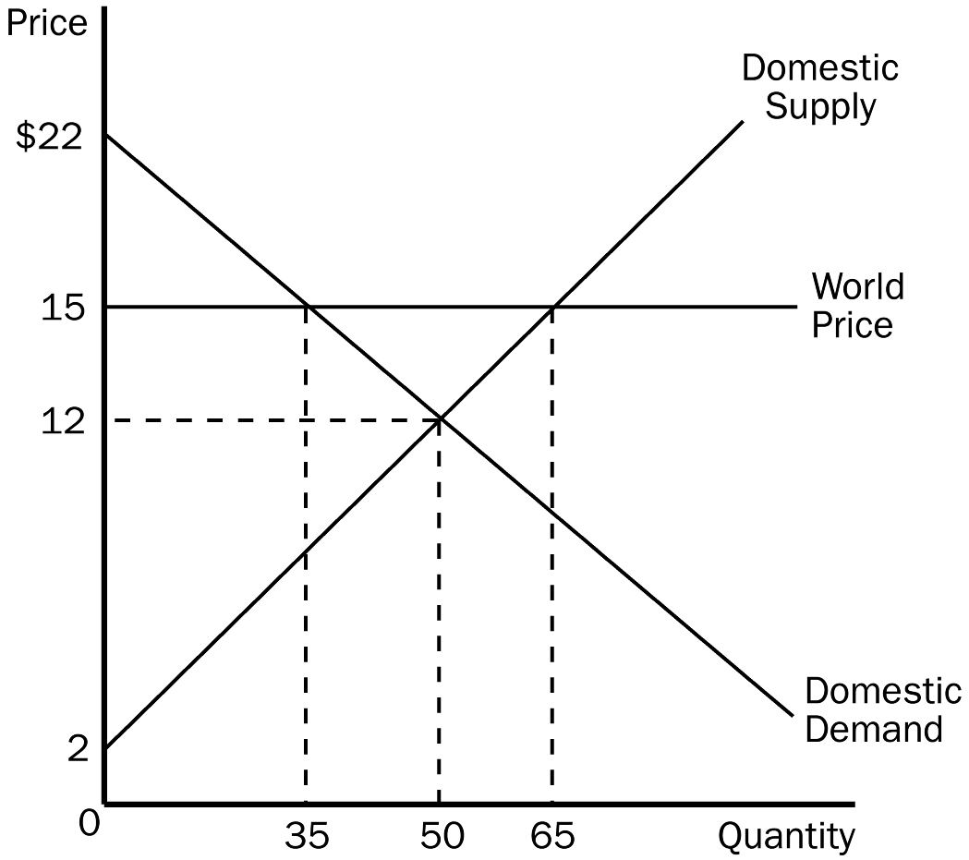
a. What is the equilibrium price of CDs before trade?
b. What is the equilibrium quantity of CDs before trade?
c. What is the price of CDs after trade is allowed?
d. What is the quantity of CDs exported?
e. What is the amount of consumer surplus before trade?
f. What is the amount of consumer surplus after trade?
g. What is the amount of producer surplus before trade?
h. What is the amount of producer surplus after trade?
i. What is the amount of total surplus before trade?
j. What is the amount of total surplus after trade?
k. What is the change in total surplus because of trade?
ANSWER:
a. $12
b. 50
c. $15
d. 30
e. $250
f. $122.50
g. $250
h. $422.50
i. $500
j. $545
k. $45
TYPE: S SECTION: 2
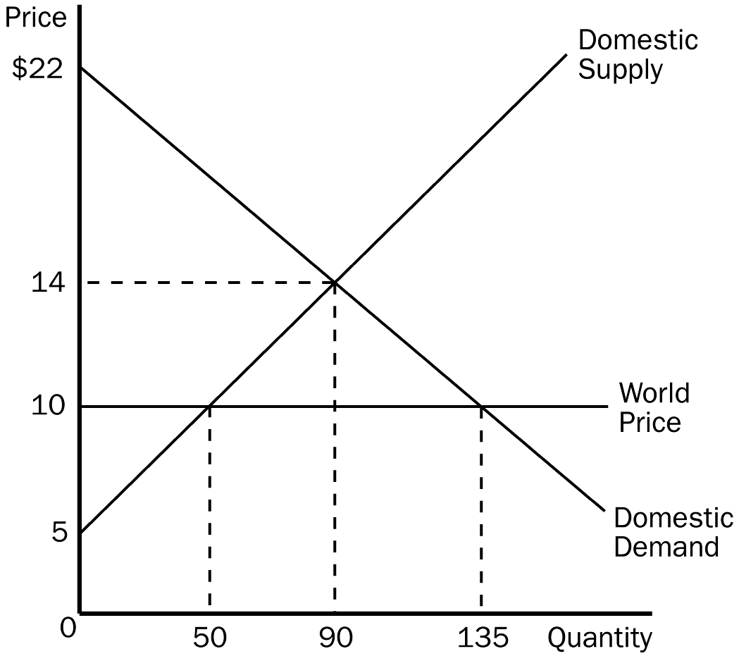
2. According to the graph shown, answer the following questions about hammers.
a. What is the equilibrium price of hammers before trade?
b. What is the equilibrium quantity of hammers before trade?
c. What is the price of hammers after trade is allowed?
d. What is the quantity of hammers imported?
e. What is the amount of consumer surplus before trade?
f. What is the amount of consumer surplus after trade?
g. What is the amount of producer surplus before trade?
h. What is the amount of producer surplus after trade?
i. What is the amount of total surplus before trade?
j. What is the amount of total surplus after trade?
k. What is the change in total surplus because of trade?
ANSWER:
a. $14
b. 90
c. $10
d. 85
e. $360
f. $810
g. $405
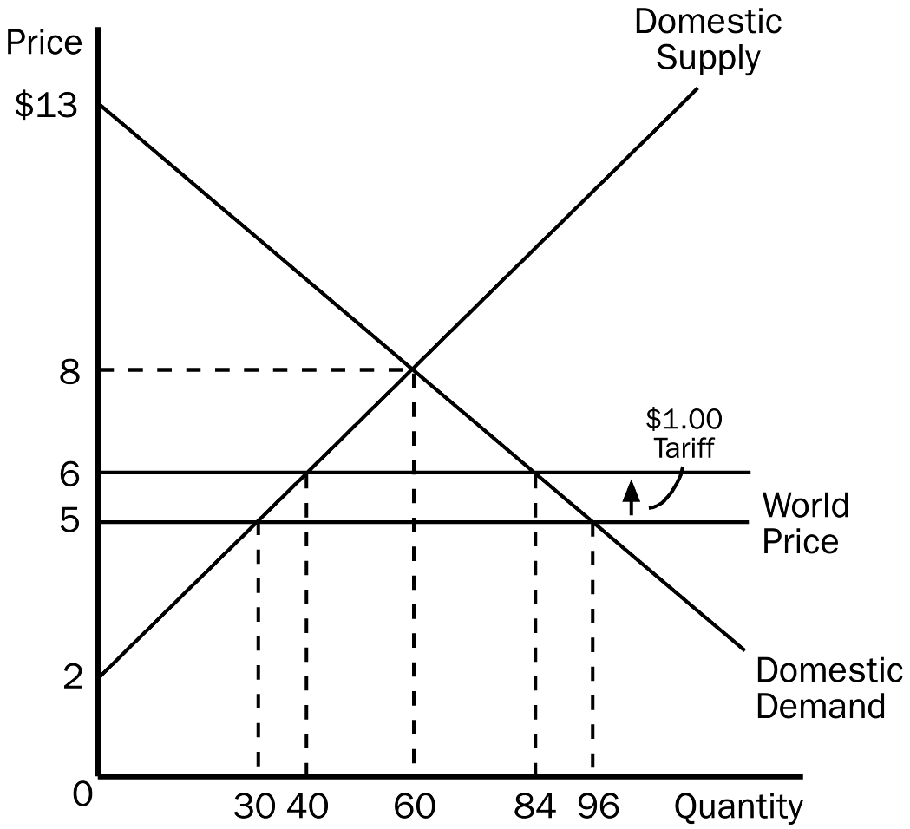
h. $125
i. $765
j. $935
k. $170
TYPE: S SECTION: 2
3.
Using the graph shown, assume that the government imposes a $1 tariff on hammers. Answer the following questions given this information.
a. What is the domestic price and quantity demanded of hammers after the tariff is imposed?
b. What is the quantity of hammers imported before the tariff?
c. What is the quantity of hammers imported after the tariff?
d. What would be the amount of consumer surplus before the tariff?
e. What would be the amount of consumer surplus after the tariff?
f. What would be the amount of producer surplus before the tariff?
g. What would be the amount of producer surplus after the tariff?
h. What would be the amount of government revenue because of the tariff?
i. What would be the total amount of deadweight loss due to the tariff?
ANSWER:
a. $6, 84
b. 66
c. 44
d. $384
e. $294
f. $45
g. $80
h. $44
i. $11
TYPE: S SECTION: 2
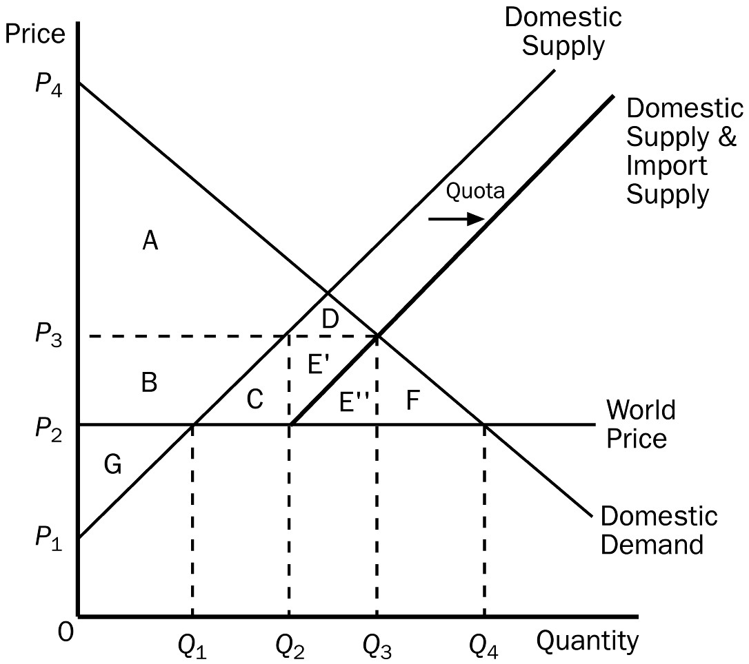
4. Using the graph shown, assume that free trade existed in this country before the government imposed an import quota of 20 hammers. Answer the following questions given this information.
a. What is the price of hammers before the quota is imposed?
b. What is the price of hammers after the quota is imposed?
c. What is the quantity of hammers imported before the quota?
d. What is the quantity of hammers imported after the quota?
e. What is the amount of consumer surplus before the quota?
f. What is the amount of consumer surplus after the quota?
g. What is the amount of producer surplus before the quota?
h. What is the amount of producer surplus after the quota?
i. What would be the amount of deadweight loss due to the quota?
ANSWER:
a. P2
b. P3
c. Q4 –Q1
d. 20 (or Q3 – Q2)
e. A+B+C+D+E’+E”+F
f. A+D
g. G
h. G+B
i. C+F
TYPE: S SECTION: 2
5. How does an import quota differ from an equivalent tariff?
ANSWER: both the import quota and the tariff raise the domestic price of the good, reduce the welfare of domestic consumers, increase the welfare of domestic producers, and cause deadweight losses. The only difference for the economy is that the tariff raises revenue for the government, while the import quota creates surplus for license holders.
TYPE: S SECTION: 2
6. Define the two approaches a nation can take to achieve free trade. Does one approach have an advantage over the other?
ANSWER: A unilateral approach is when a country removes its trade restrictions on its own. A multilateral approach is when a country removes its trade restrictions while other countries do the same. A multilateral approach has two advantages. The first is that it has the potential to result in freer trade because it can reduce trade restrictions abroad as well as at home. If international negotiations fail, however, the result could be more restricted trade than under a unilateral approach. Also, the multilateral approach may have a political advantage and can sometimes win political support when a unilateral reduction cannot.
TYPE: S SECTION: 3
7. What are the arguments in favor of trade restrictions, and what are the counterarguments? As an economist, do any of these arguments justify trade restrictions? Explain.
ANSWER: arguments mentioned in the text include the jobs argument, the national security argument, the infant industry argument, the unfair competition argument, and the protection-as-a-bargaining-chip argument. These arguments and counter-arguments are outlined in section 9-3 of the text. Most economists would dismiss the jobs argument, the infant industry argument, and the unfair competition argument on strictly economic grounds. The bargaining-chip argument carries high risks of economic harm if the threat doesn’t work. The national-security argument balances economic loss from trade restriction against the benefit of long-term national survival, and is probably the argument that economists would most likely buy if it were clear that the industry being protected was clearly crucial to national security.
TYPE: S SECTION: 3

